**BasketXpertPOS: Where Intelligence Meets Efficiency**

Bachelor of Science in Computer Science Non-STEM 3A

In Partial Fulfillment of the Requirements in  
 Software Engineering 2

Submitted by:

Capoquian, Juliana Anne

Espinosa, Princess Nichole

Macapobre, Jhon Lloyd

Orain, Jieson

So, Kyle Vencell

Submitted to:

Prof. Dolores L. Montesines

June 2024

**Acknowledgement**

Team 5 Stars would like to express their profound gratitude first and foremost to Prof. Montesines for her hard work and dedication to the subject and to install knowledge among her students particularly from the course CS351L Software Engineering 1.

The team would also like to thank their family, parents, siblings and more for their unwavering support and their faith that we, as students, will get through these challenges for a better life in the future.

The team would also like to thank friends, colleagues and mentors who have given us advice, help and insights about the project. We are also expressing our gratitude to Salon D-Eliz for letting their business be a beneficiary of this project. And lastly, to Almighty God for serving as a shining light and a beacon of hope for everyone, not only us, but also to everyone involved in this project.

-Yana

-Nics

-Lloyd

-Jie

-Kyle

**ABSTRACT**

In today's business world, combining intelligence with efficiency is important. This research works on the development of BasketXpertPOS, a Point of Sale (POS) system that aims to revolutionize transactions by seamlessly integrating cashless payments with Market Basket Analysis. With an emphasis on the business Salon D-Eliz, the system offers to simplify operations, improve client experiences, and provide invaluable insights into consumer behavior. Using the Python programming language and PyQt5 for the user interface, this project not only addresses technical issues but also investigates the wider effects of merging Machine Learning and Business Analytics into traditional systems. This research aims to prepare for future advancements in the world of cashless transactions and intelligent POS systems.

***Keywords:*** *BasketXpertPOS, Point of Sale System, POS, Market Basket Analysis, Cashless Payment, Salon D-Eliz*

**TABLE OF CONTENTS**

Title 1

Abstract 2

Table of Contents 3

**CHAPTER 1 THE PROBLEM AND ITS BACKGROUND 6**

Introduction 5

Background of the Study 7

Objectives of the Study 9

Significance of the Study 9

Scope and Delimitations 10

**CHAPTER 2 CONCEPTUAL FRAMEWORK 12**

Review of Related Literature and Study 12

Conceptual Model of the Study 15

System Architecture of the Study 19

Definition of Terms 22

**CHAPTER 3 METHODOLOGY 23**

System Design 23

Project Development 30

**CHAPTER 4 RESULTS AND DISCUSSION 33**

Project Description 33

Project Structure 34

Project Capabilities and Limitations 51

Project Evaluation 53

**CHAPTER 5 57**

SUMMARY OF FINDINGS 57

CONCLUSIONS 57

RECOMMENDATIONS 58

##### 

##### 

##### **CHAPTER 1**

##### **PROBLEM AND ITS BACKGROUND**

This chapter contains the introduction or the background of the study, the project objectives, scope and limitations, as well as the significance of the study. Additionally, it will give a synopsis of the research and a brief discussion of the principles that were employed.

##### **Introduction**

Cashless transactions have been rampant in today's world for its efficiency and benefits. By definition, cashless transactions are any type of monetary transaction that is carried out without the exchange of actual cash [1]. Credit and debit cards, digital wallets, cryptocurrency, and bank transfer payment methods can be used in this transaction. As technology continues to emerge in today’s society, cashless payments are more recognized and applied by customers and businesses. As a matter of fact, a few European nations have gone nearly entirely cashless, with the remaining nations following behind. Also, some countries like Sweden aim to be totally cashless in the future [2]. Since the COVID-19 outbreak, cashless transactions have become more widespread in the Philippines. People opt to use non-physical payment methods to avoid contracting the virus. According to Jeffrey Navarro, the country manager for Visa in the Philippines and Guam, 50% of customers carry less cash in 2022 as more of them use cashless payment methods like cards, mobile wallets, and quick response (QR) payments [3]. Solutions and systems that cater to cashless transactions are marketable nowadays.

For any cashless transaction to be completed, a Point of Sale system that supports cashless payments is required. A Point of Sales, or POS, is a device that retail customers use to execute transactions [4]. In addition to that, retailers can process payments and keep track of their sales through POS systems. Integrating cashless payment in POS is a great tool that is beneficial for both business owners and customers.

In the light of Machine Learning, Market Basket Analysis is a prominent technique that helps businesses market their products proficiently. An article written by TechTarget Contributor [5] states that retailers utilize Market Basket Analysis (MBA), a data mining approach, to better understand client purchase patterns and boost sales. It entails evaluating massive data sets, such as purchase histories to identify product groupings and items that are likely to be purchased together.

The goal of this project is to incorporate these concepts into a system. The BasketXpertPOS is a Point of Sale system that accepts cashless payments, tracks and saves the daily sales report for the retailer, and applies Market Basket Analysis to further understand customer purchase patterns that could enhance the sales of Salon D-Eliz. The system caters to an easier and more efficient way to store the salon’s everyday transactions. It aims to prove the efficiency of the Point of Sales system for both the business and customers while integrating Machine Learning through Market Basket Analysis.

##### Background of the Study

Prior to the development of technology, the traditional way of tracking and keeping transaction records was through bookkeeping. The traditional approach to bookkeeping involves manually recording every transaction in a journal; this method does not fully leverage digital technology and instead relies on paper records. Manual bookkeeping records are kept in ledger books, journal registers, and other paper-based books of accounts. Small enterprises with simpler transactional processes, like Salon D-Eliz, often adopt this method of bookkeeping. Although it needs a lot of time and expertise, it is less expensive and easy to maintain [6]. However, this method is not systematic enough for larger businesses and faces a number of challenges in its implementation. These challenges involve [7]: labor-intensive and time-consuming, prone to human errors, limited accessibility, and scalability issues. For this reason, digital bookkeeping was known. Digital bookkeeping is a method of maintaining entirely digital financial records. This technique makes use of software programs integrated with automatic data gathering and analysis capacities, like Excel application software, rather than manual entries or paper-based records [8]. However, the lack of utilization of the user interface makes the inputting of data demanding because the users are required to type every single word across the software application being used to record transactions. Utilization of the Point-of-Sale system as a means to provide a user-friendly program for the advancement of transaction record handling is a systematic and efficient way to eliminate these difficulties every business encounters.

A POS or point-of-sale is a device that is used to process transactions by retail customers [9]. These transaction records processed by the POS will serve as the input data for the business’ database. This method is not only efficient for both the customers and the business workers but also eradicates human error inputs into the database. The database contains all the transaction records of the business, including the information of the customers and the products they availed.

The BasketXpertPOS system is a Point-of-Sale system utilizing a database management which automatically records every transaction and stores them in a file accessible for the business admin. This is to provide advancement to the current manual bookkeeping method of the client, Salon D-Eliz. The POS has a graphical user interface (GUI) which helps the workers easily input the transaction and customer information into the database. The inclusion of Market Basket Analysis is also an effective way to improve sales of the business.

##### **Objectives of the Study**

The general objective of the study is to design a user-friendly POS system that can save transactions and information in a database and integrate Market Basket Analysis. Specifically, the study aims to:

1. Implement a pointing system for every customer in the salon. Every customer has a unique key, containing the user’s personal information and their current point balance that is accessible through the database. The balance can be used by the customers to pay for their transaction bills.
2. Enable the admin to add and modify user accounts and perform actions that may involve non-physical money or point balance.
3. Store every transaction in a database and authorize the admin to delete and modify transactions from the database.
4. Generate daily sales reports that can only be accessed by the retailers.
5. Integrate Market Basket Analysis based on the transaction data of the customers.

##### **Scope and Limitations**

The project will focus on the POS system that caters to every service available in the salon, transactions, and user accounts storage in the designed database, generation of daily sales reports, and the application of market basket analysis. PyQt5 is utilized to design the user interface (UI) of the system, and Python is used for the system’s backend programming. The project will only focus on the establishment Salon D-Eliz. The system will revolve around the parameters of the client. The program is also incapable of applying new item/s for offered services automatically. Should that appear to be the case, it may need to be added manually by the developers.

##### **Significance of the Study**

This study will make use of system development fundamentals and incorporate them with ideas that came from the field of Machine Learning and Business Analytics. Alongside exercising a systematic POS system and efficient payment transactions, this study will promote the use of Business Analytics and Machine Learning to enhance traditional systems and give them a more dynamic usage in their respective fields of deployment. Also, this study aims to benefit the following:

1. Business Establishments: Long gone the traditional hand-written ledgers, businesses can have a time-wise and efficient way to record all of their transactions with minimal human errors. Through the use of this system, businesses can have a more dynamic system that involves transactions with a touch of Machine Learning and Business Analytics.
2. Customers: Customers will find the system more convenient as they will no longer need to bring their physical money which is prone to theft and other incidents. The system will also offer a variety of services such as increasing the load of balance and modification of user account information.
3. Researchers: This project will immensely benefit the researchers as it will exercise the use of Machine Learning and Business Analytics in traditional Information Systems, gaining new knowledge and breakthroughs along the way.
4. Future Developers/Researchers: This study can help other developers to come up with or look for different angles on how to make a traditional system more dynamic with the use of emerging technologies such as data analytics.

##### 

##### **CHAPTER 2**

**CONCEPTUAL FRAMEWORK**

This chapter provides a more profound discussion of the review of related literature, related studies, the conceptual model of the study, and the operational definition of terms relevant to this study. Chapter II expounds on the concepts discussed in the paper by providing supporting materials that will enable the developers to further understand the study.

**Review of Related Literature and Study**

##### *Point of Sales (POS) system*

##### The Point of Sales (POS) system is a great tool that benefits retailers in terms of its efficiency. Point of sale (POS) systems employ hardware and software to record retail sales transactions in retail stores [10]. Some of its advantages include: that it facilitates faster and easier payments, reduces data mistakes, improves client management, offers uncomplicated data access, aids in cost savings, and automatically provides reports for analysis [11]. POS system computes the purchase amount for a customer, including sales tax, authorizes the payment, and records the transaction's time and date [12]. This system can be combined with hardware such as kiosks, card and debit card readers, cash drawers, receipt printers, and barcode scanners to input and output data from the system. A study by Khalid & Mand [13] entitled “Point of Sale System” presents the use and benefits of POS. Their system generates a complete sales and inventory system by which customers and partners can quickly access sales and inventory situations.

##### *Market Basket Analysis*

According to Sjarif, et. al [14], Business insight (BI) is an information-driven framework that includes a range of tools, developments, applications, processes, and techniques that enable the extraction of valuable knowledge and data from operational information resources. Making well-informed and strategic decisions also benefits from the identification of hidden patterns or trends gleaned from the massive amount of data. Market basket analysis (MBA) is one of the regularly utilized data mining techniques in BI to help business organizations accomplish the upper hand. Market Basket Analysis examines patterns of co-occurrence to assess the strength of the relationship between products that are purchased together [15]. It analyzes large amounts of data sets, such as sales invoices, to determine the purchasing behavior of the customers and use this information for the benefit of the business. This data mining technique provides multiple advantages such as customer satisfaction, maximizing product placement, providing special deals, and developing new product bundles to boost sales from the frequently purchased products [16]. A research study entitled “Market Basket Analysis: Trend Analysis Of Association Rules In Different Time Periods” authored by Ansari [17] demonstrates the broad applicability of market basket analysis and how, when time is taken into consideration, it can be used to solve a number of issues in a much more effective and efficient manner.

##### *Apriori Algorithm*

In any association rule mining technique such as Market Basket Analysis, Apriori is frequently applied. The data scientists often refer to the Apriori method to find frequently occurring objects in the database. This approach is particularly effective for huge data sets when meaningful correlations between the elements need to be found [22]. This algorithm repeatedly scans the database. It searches through database objects using the breadth-first approach [18]. The Apriori algorithm contains three components: confidence, support, and lift. According to Shetty [19], support provides us with an indication of an item set's popularity based on the percentage of transactions in which it appears. Transactions with many items purchased in one transaction are shown by support. Meanwhile, transactions when the items are bought one after the other are demonstrated by confidence. It answers the question, “How probable it is that item Y will be bought when item X is bought?”. And lift controls for item Y's popularity and displays the likelihood that item Y will be bought when item X is. A study conducted by Behera et.al [20] entitled “Market Basket Analysis based on Frequent Itemset Mining” used the Apriori algorithm for Market Basket Analysis. The study proved the effectiveness of the aforementioned algorithm in conducting the association mining technique, Market Basket Analysis.

##### *Cashless Transactions in POS*

Cashless transactions include the acceptance or payment of goods or services without the need for actual money. This covers payments made online using any method that eliminates the need for currency, such as credit/debit cards, cheques, E-wallets, and others [21]. This mode of payment has lots of benefits. Among them include [22]: (1) Convenience. Through cashless transactions, customers would not need to go to ATMs to withdraw their money from their bank accounts. (2) Security. Carrying large sums of cash is eliminated with cashless transactions, which lessens the possibility of theft or loss. Also, transactions are secure since they contain encryption for protection. (3) Economic benefits. Currency printing costs are decreased by cashless transactions. Moreover, with easy traceability, it can deter black money and illicit transactions, leading to a more robust economy.

A study entitled “Cashless Transaction Through E-Wallet: Analysis Of Perception And Usage Intention Of Micro Business Owners In Cavite” by (Saquin et al., n.d.) [23], concludes that e-wallets are perceived positively and are likely to be adopted for business transactions, enhancing financial management and security for micro-business owners. Micro-business owners find e-wallets to be accessible, convenient, and secure. They agree that e-wallets are easy to use and can save time during transactions. The research suggests that there is a strong intention among owners to use e-wallets for business transactions, especially due to benefits like rewards and the convenience of not having to carry cash.

Allowing cashless payments and integrating this mode of payment in POS opens a variety of opportunities for both customers and businesses. Hence, the application of a pointing system as a means of cashless payments solely for the client’s business can be a great tool to encourage frequent customers to avail more of the salon’s services, and a way to market the business to the general public.

##### Conceptual Model of the System

The provided figure (fig.1) demonstrates the study's input, method, and output, emphasizing the need of developers extensively analyzing present operations and investigating relevant concerns before obtaining a desired outcome. This conceptual model provides an extensive overview of the system's components and interconnections, allowing for a better understanding of client customer buying habits and improving business decision-making processes.

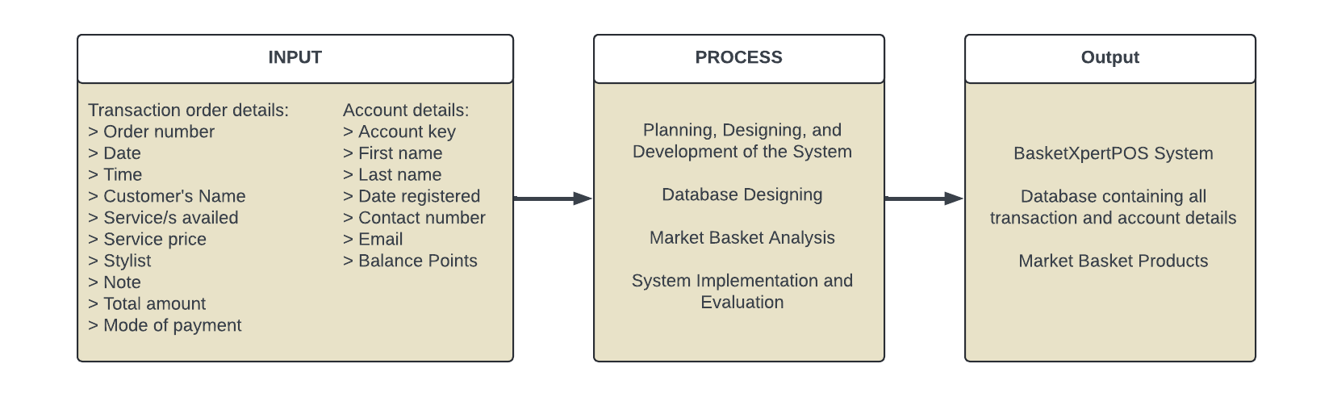

**Fig 1. Conceptual model of BasketXpertPOS System**

**INPUT**

All the data required for the operation and functionality of the BasketXpertPOS system shall be included in the input phase. Transaction order details and account details shall be classified as input.

1. **Transaction Order Details:**

* **Order Number:** Unique identifier for each transaction.
* **Date:** Date of the transaction.
* **Time:** Specific time of the transaction.
* **Customer’s Name:** Customer Name.
* **Services Availed:** List of services purchased.
* **Service Price:** Cost associated with each service.
* **Stylist:** Professional who provided the service.
* **Note:** Additional remarks or instructions.
* **Total Amount:** Cumulative cost of the transaction.
* **Mode of Payment:** Payment method used.

1. **Account Details:**

* **Account Key:** Unique identifier for each customer account.
* **First Name:** Customer first name.
* **Last Name:** Customer last name.
* **Date Registered:** Date of account registration.
* **Contact Number:** Customer phone number.
* **Email:** Customer’s email address.
* **Balance Points:** Loyalty points or credits associated with the account.

**PROCESS**

Key activities to transform input data into meaningful outputs are included in the process phase:

* **Planning, Designing, and Development:**

In this initial stage, it involves conceptualization and architectural design of the BasketXpertPOS system. It also involves specifying the requirements of the system. drawing up design specifications and developing a framework for it.

* **Database Design:**

This process aims at the organization of input data into a structured format so that they can be effectively stored, effectively, stored, and retrieved and managed. It is intended to define database schemas, establish relationships between data entities and apply data integrity requirements.

* **Market Basket Analysis:**

By examining the relationship of various products and services, this analytical process has identified patterns in customer buying behavior. Insights gained inform the management of inventories promotional strategies and cross selling opportunities.

* **System Implementation and Evaluation:**

The BasketXpertPOS system shall be fully developed, tested and implemented in this phase. Postdeployment, the system shall be evaluated according to predefined criteria with a view to ensuring that it is able to meet user requirements and operate effectively.

**OUTPUT**

The output phase generates final products and result from processed input data:

* **BasketXpertPOS System:**

Developed point-of-sale system (POS) integrating all functionalities required for efficient transaction management and customer service.

* **Database Containing All transactions and Account Details:**

Comprehensive database consolidating all processed input data, providing a reliable repository for transaction and account information.

* **Market Basket Products:**

A list of products identified by market basket analysis which highlights items frequently purchased with each other and enables targeting marketing and sales strategies.

##### System Architecture

System architecture is an essential feature of any complicated system, providing a comprehensive overview of the structure, behavior, and interactions within that system. It is a conceptual model that defines the relationship between the various components and facilitates a deep understanding of how the system works and how it can be optimized for performance, scale, and reliability. In order to ensure that the system fulfills its objectives and requirements, it is of fundamental importance for an efficient system architecture providing a basis for development, construction and deployment.

This chapter focuses on the system architecture of BasketXpertPOS, a point of sale system implemented with a Market Basket Analysis Algorithm. This chapter aims to provide a comprehensive understanding of the system architecture and its role in meeting the objectives, by providing an accurate description of the system's components, interaction, and views.

In order to provide a clear and concise overview of the structure and behavior of the system, the system architecture is presented in combination of models, descriptive text and diagrams. This chapter is organized into sections that cover the key components, interactions, and views of the system, thus helping the reader to understand and follow easily the architecture of the system.

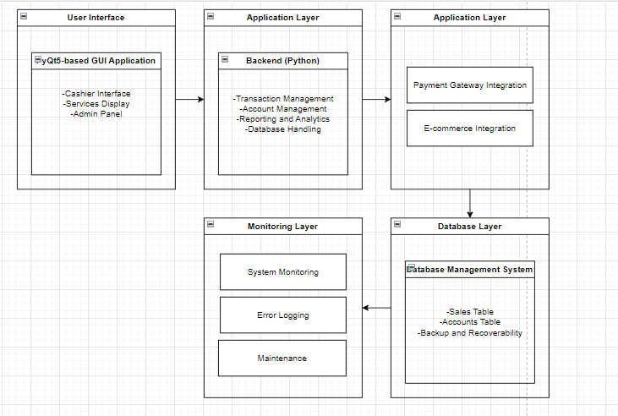

**Fig 2. System Architecture of BasketXpertPOS System**

1. **User Interface Layer (Frontend)**

Technology Used: PyQt5

Components:

* **Cashier Interface:** Streamlines transaction processing by providing an improved user experience and robust error handling.
* **Customer Display:** Clearly and concisely present transaction details to customers with a user-friendly interface.
* **Manager Interface**: Allows access to comprehensive reports and management features through easy-to-use navigation.

1. **Application Layer (Backend)**

Technology Used: Python

Components:

* **Transaction Management:** Utilizes advanced logic to process sales, returns, and exchanges, handling complex transactions efficiently.
* **Account Management:** Handles customer data, balance, and other necessary data about the customer.

**-Database Handling:** Handles the database management for its contents and structure.

1. **Integration Layer**

Components:

* **Payment Gateway Integration:** Establishes connections with various external payment processors to ensure secure and dependable transactions
* **E-commerce Integration:** Synchronizes with online sales platforms to facilitate smooth order management and updates to inventory.

1. **Database Layer**

Components:

* **DBMS:** The storage of all POS data including transactions, inventory, customer, and employee information.
* **Backup & Recovery:** The process of regularly backing up data and ensuring it can be recovered when needed.

1. **Monitoring and Maintenance Layer:**

Components:

* **System Monitoring:** Monitors system performance and health continuously and sends alerts in real-time.
* **Error Logging:** Captures system errors to aid in troubleshooting and debugging.
* **Maintenance:** Ensures the POS system's security and efficiency through regular updates and system maintenance.

##### Definition of Terms

**Apriori Algorithm -** Apriori algorithm refers to the algorithm which is used to calculate the association rules between objects. It means how two or more objects are related to one another.

**BasketXpertPOS** - Is a Point of Sale (POS) system that aims to revolutionize transactions by seamlessly integrating cashless payments with Market Basket Analysis.

**Cashless Transactions -** A cashless transaction is an automated or online exchange between two individuals, businesses, or organizations. A digital transaction is a cashless transaction in which no paper is used to carry out the transaction.

**E - Wallet -** An E-Wallet, also known as an electronic wallet or mobile wallet, goes a long way towards facilitating frictionless purchases. Use near-field communications technology to enable consumers to make [contactless payments](https://gocardless.com/guides/posts/pros-cons-of-contactless-payments/) using their mobile device, tablet or smart watch instead of using a physical card.

**Market Basket Analysis** - Market basket analysis is a data mining technique that analyzes patterns of co-occurrence and determines the strength of the link between products purchased together.

##### Point of Sale System - The point of sale, or point of purchase, is where you ring up sales for customers. When customers check out online, walk up to your counter, or pick out an item from your stand or booth, they're at the point of sale.

##### 

##### **CHAPTER 3**

##### **RESEARCH METHODOLOGY**

This chapter provides a detailed discussion of the project design, development, operating and testing, and evaluation process of the system methods as well as the procedures that the developers will conduct, and the proposed flow of the steps to be completed to accumulate information essential for the study.

**System Design**

The project BasketXpertPOS: Where Intelligence Meets Efficiency for Salon D-Eliz is a system built using Python Programming Language, utilizing PyQt5 for the graphical user interface (GUI), alongside MS Access as its database. A context diagram below shows the data flow and relationship of the system to the external entities.

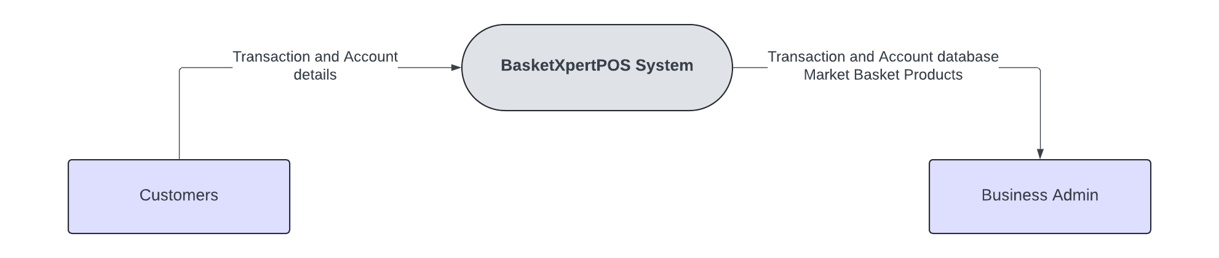

**Fig 2. Context Diagram of the System**

The external entities in the context diagram are the salon customers and the business admin. The customer’s transaction and account details are the input for the system. After processing these data, the transaction and account database as well as the market basket products will be delivered to and accessed by the business admin. These will serve as the output of the system. Also, the context diagram also depicts the data flow diagram (DFD) level 0 of the system.

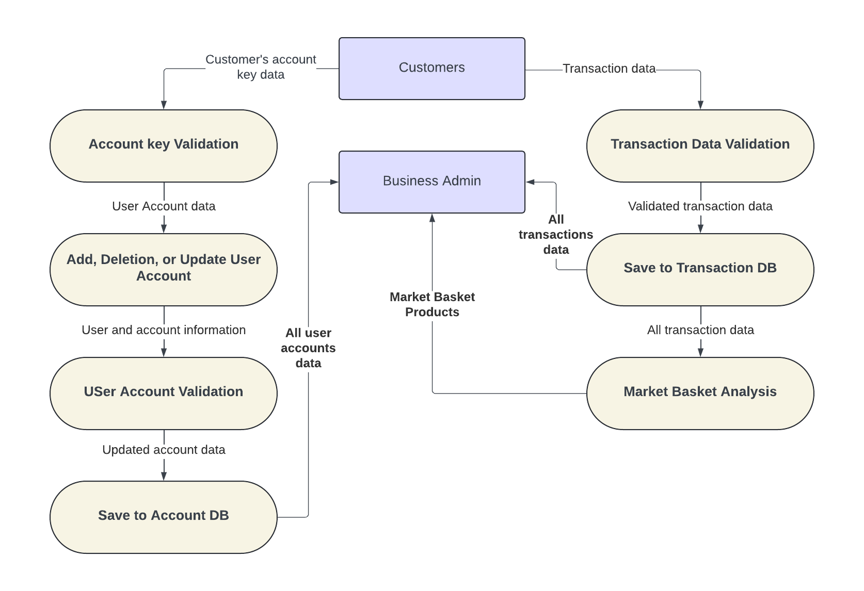

**Fig 3. Data Flow Diagram (DFD) Level 2 of the System**

The diagram above shows a data flow process where customer account and transaction data are validated, updated, and stored. Customers provide account key data, which goes through validation and is then used to add, delete, or update user accounts. This updated account information is further validated and saved in the Account Database. Simultaneously, transaction data from customers is validated and stored in the Transaction Database. All user account and transaction data are sent to the Business Admin, who uses it for market basket analysis to identify product purchase patterns. The results help the Business Admin understand customer buying behavior and make informed decisions.

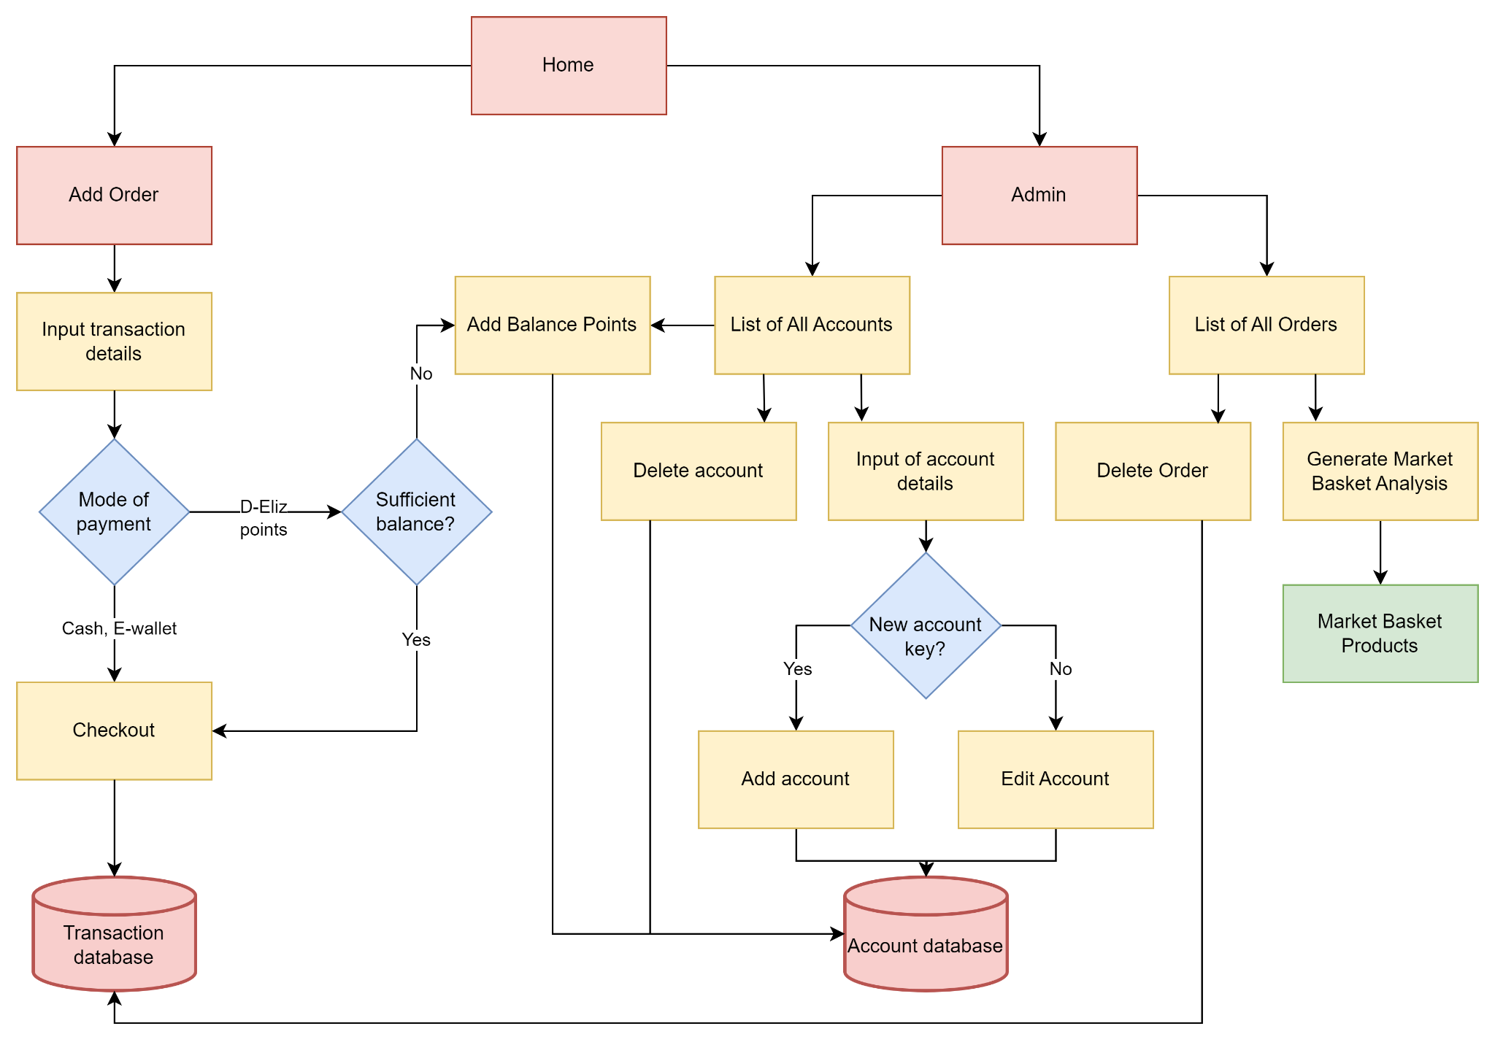

**Fig 4. Block Diagram of the System**

The system design of the project is made using a block diagram, a system diagram in which the parts are represented by blocks connected by lines that illustrate the blocks' connections. The diagram shows the different parts of the application starting first with home wherein the system user can choose between add order or admin menu. The block diagram shows how a customer places an order. They browse, add items, choose payment (including loyalty points), and confirm. The system stores the order details and allows admins to manage accounts, orders, and analyze purchasing trends.

##### 

**Fig 5. Use Case Diagram of the System**

The figure above shows the use case diagram of the project which shows the graphical depiction of a system user and admin’s possible interactions with the application. This shows how the system user and admin are expected to interact with the application, and the requirements, actions, and functionality of the application.

The features of the BasketXperPOS on user-to-application are:

### **Customer**

* Avail service/s - the customer’s order will be entered into the system through the system user.

### **System User**

* Select service items - the user can browse and input the service/s availed by the customer.
* Input price, stylist, and note - the inputs must be valid.
* Add to billing information - the order information, such that the service availed, price, stylist, and note will be shown to the user interface.
* Input customer's name
* Choose payment method - payment method choices include Cash, E-Wallet, and D-Eliz Points.

### **Admin**

### View all transaction orders

* Search - searching orders through specified details.
* Delete order - deleting an order in the database.
* Generate MBA - generate market basket analysis products using all transaction orders.

View all user accounts

* Search
* Add account - add an account using the input data.
* Delete account - delete an account in the database.
* Update account - edit and update the details of an account.
* Add balance points - add D-Eliz points to an account.

##### **Database Design**

**Fig 6. Entity Relationship Diagram (ERD) of the System Database**

**Account and Customer:**

In the system each customer has a separate account which contains his or her personal information and balances. Each account is linked to a single customer by the CustomerID in the Account Table.

**Transaction:**

Details such as order number, date time, total amount, and payment method are captured in every transaction record. The transaction is linked to the customer who made it by CustomerID in the Transaction table.

**Service and Transaction Services:**

Services are individually offered, such as haircuts or massages with their own identifier and attributes. The TransactionService table links services to transactions, handling the many-to-many relationship by associating multiple services with a single transaction and vice versa.

**System user and Admin:**

System users may be a regular user or admin of the system. Admin have specific privileges and are defined by the Admin Table, which is a subtype of System User. User management and role based access control are supported by this structure.

##### **Project Development**

**Phase 1:**

Phase 1 is a process that needs to be started with careful planning. Often referred to as the planning phase, its goal is to guarantee that all scheduled tasks are carried out and that the development process is thoroughly monitored. Establishing a clear project management workflow that addresses the full project development lifecycle is the primary goal of the planning phase. The developers must divide the bigger tasks into smaller, easier-to-manage pieces. It assists in predicting the amount of time needed for each activity and identifying the resources—people, tools, etc.—necessary to effectively finish the eSports video highlight generator project. Below is the project timeline of the system development visualized using Gantt chart. The purpose of the chart is to provide detailed task planning, each specified task with time duration, to keep track of the system’s progress.

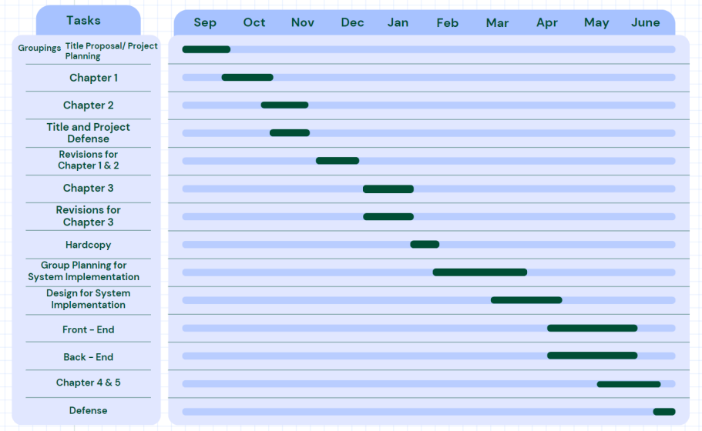

**Fig 7. Project Timeline using Gantt Chart**

**Phase 2:**

Phase 2 will address all pertinent components of additional planning and design after the planning phase's initial study or analysis of the system requirements is completed. In the second phase, the developers will offer a thorough and precise explanation or definition of: (1) The people who will utilize the system, or its users. (2) The system's intended purpose, or what it is supposed to accomplish. (3) Particular information regarding how the system will be operated, such as the time at which the system will be utilized or run and the place where the system will be installed or utilized.

The developers will assess the new system's viability and make sure it satisfies the demands and specifications of its intended customers. This feasibility study will assist in ascertaining if the new system can reasonably and successfully meet the needs of the users. Apart from the feasibility analysis, the developers will carry out a comprehensive evaluation to pinpoint any restrictions or limitations that could be imposed on the novel technology. The results of this constraints/limitations assessment will be useful in determining the new system's viability (i.e., whether it is practically feasible) and compatibility (i.e., whether it is compatible with the infrastructure, other systems, etc.).

**Phase 3:**

The third stage of the project development process is dedicated to technical planning and designing. This stage outlines the system's coding process from the front end to the back end. The BasketXpertPOS system is built using Python programming language, utilizing PyQt5 as its graphical user interface (GUI). Furthermore, the Market Basket Analysis is integrated using the aforementioned programming language. The database is through MS Access.

Python is renowned for having a wide range of libraries that make programming easier and more effective. In the system’s backend, multiple Python libraries are imported in accordance to the system’s requirements, particularly for the Market Basket Analysis. Also, the GUI design is based on the color palette of the Salon itself, it is to incorporate the uniqueness of the store to the POS system.

The system's objective is to combine the aforementioned technical designs to generate an output that meets user expectations. It should be emphasized that every aspect of the project, including crucial protocols and front- and back-end design blueprints, needs to be considered throughout the system developing phase. Every notion and detail needs to be correctly integrated into the system.

**CHAPTER 4**

**RESULTS AND DISCUSSION**

This chapter contains the project description, project structure, project capabilities and limitations, and project evaluation.

**Project Description**

In today's adapting business environment, the combination of intelligence and efficiency is essential. The BasketXpertPOS project offers to change transactions by seamlessly combining cashless payments with Market Basket Analysis. Designed specifically for Salon D-Eliz, this point-of-sale (POS) system simplifies operations, improves client experiences, and gives essential insights into consumer behavior.

The architecture of the system relies on Python programming for backend functionality, with PyQt5 powering the user interface. BasketXpertPOS not only solves technological difficulties, but also investigates the larger impacts of combining Machine Learning and business analysis with traditional systems. It discovers patterns, provides personalized offers, and optimizes inventory management through analyzing transaction data. The system's real-time analytics enable Salon D-Eliz to make decisions based on data, improve customer satisfaction, and improve profits.

This study establishes a path for future advances in cashless transactions and advanced POS systems. As businesses increasingly use digital payment methods, BasketXpertPOS leads the way in bridging the gap between intelligence and operational efficiency.

**Project Structure**



The home page of Salon D-Eliz includes a warm welcome message inviting customers to experience a high level of care and attention in an elegant and relaxing environment. It highlights the salon's commitment to making beauty their passion. The page provides an overview of the salon's services, mentioning that their team of stylists and beauty experts offer personalized experiences ranging from precise haircuts and vibrant coloring to luxurious spa treatments. Additionally, it includes contact information, such as the salon's address, phone number, and email. The page is visually enhanced by images showing the salon's decor and a vibrant workplace.

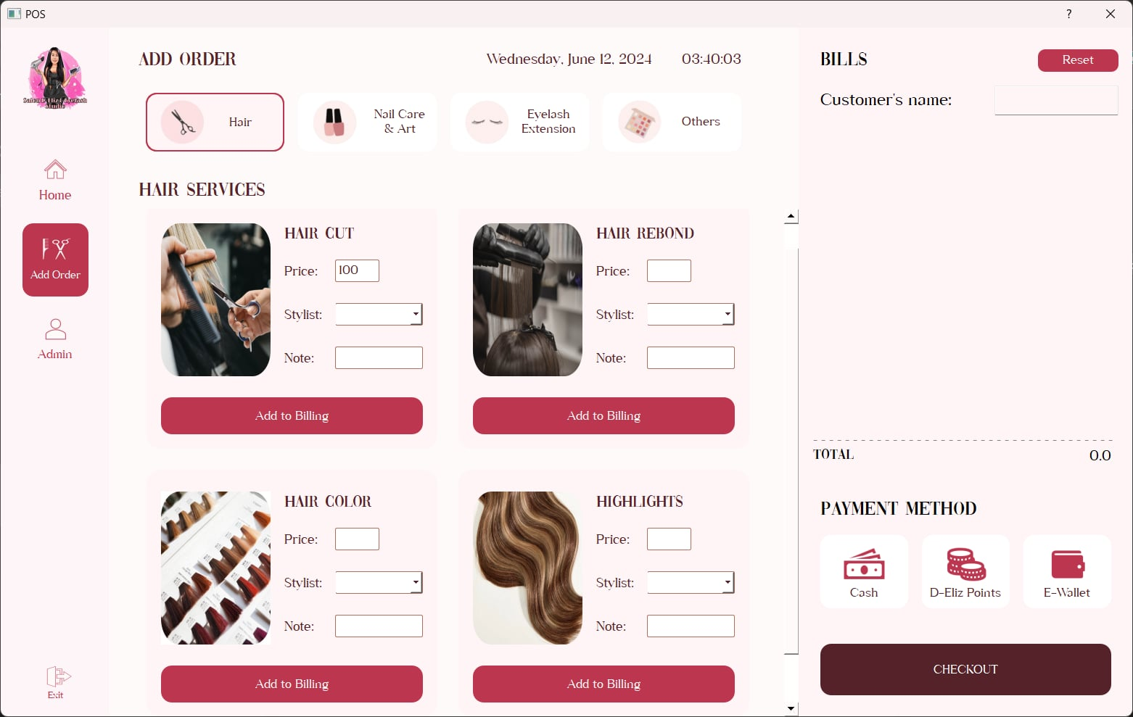**Add Order Interface**

The Figure above shows the Hair Services section allows users to select services like Hair Cut, Hair Rebond, Hair Color, and Highlights, with inputs for price, stylist, and notes, and then add 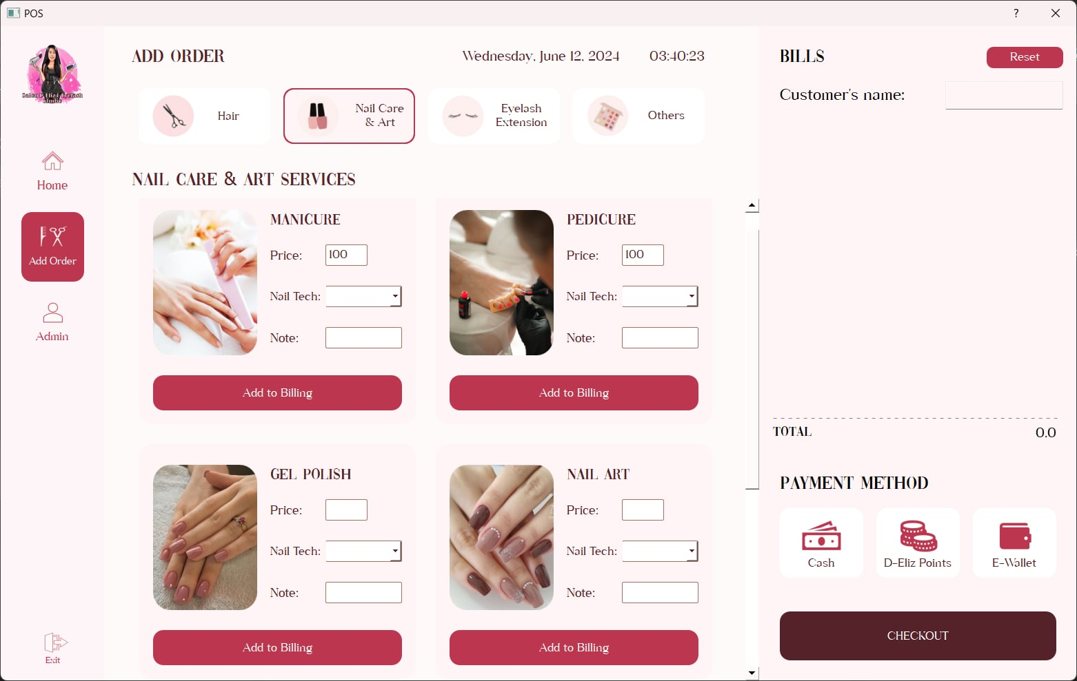them to the billing section.

The Figure above shows the Nail Care & Art Services section allows users to add services like Manicure, Pedicure, Gel Polish, and Nail Art to the billing section, with inputs for price, nail technician, and notes.

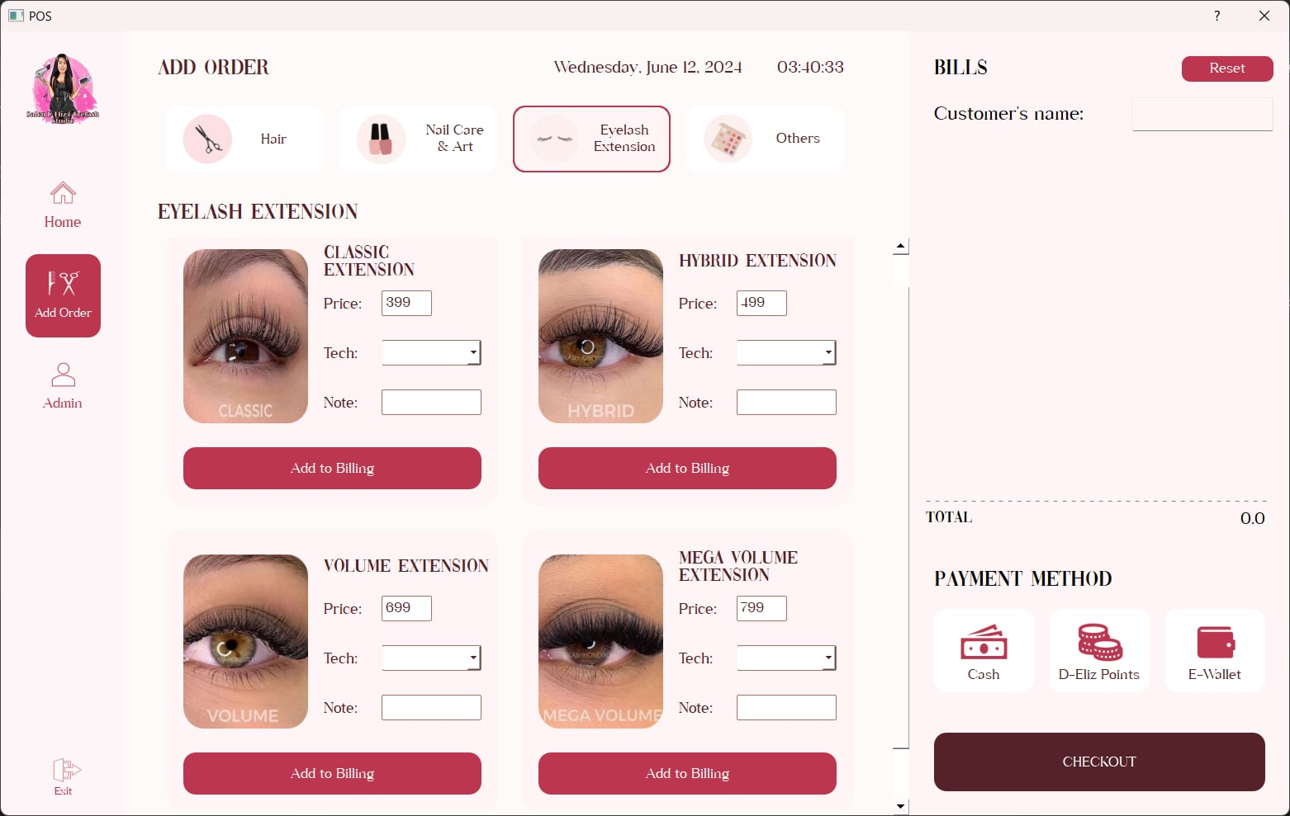

The image above shows the Eyelash Extension Services section allows users to add services like for Classic, Hybrid, Volume, and Mega Volume extensions to the billing section, including input price, technician and notes.

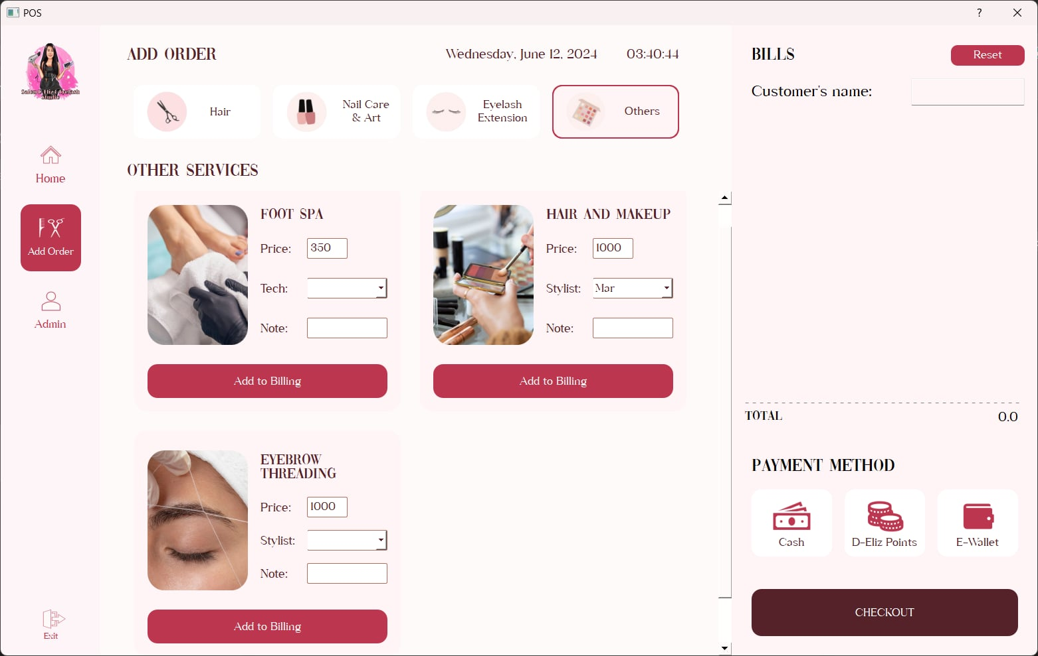

The Figure above shows the Other Services section allows users to add services like Footspa, Hair and Make-up , also the Eyebrow Threading and add to the billing section, including input price, technician and notes.

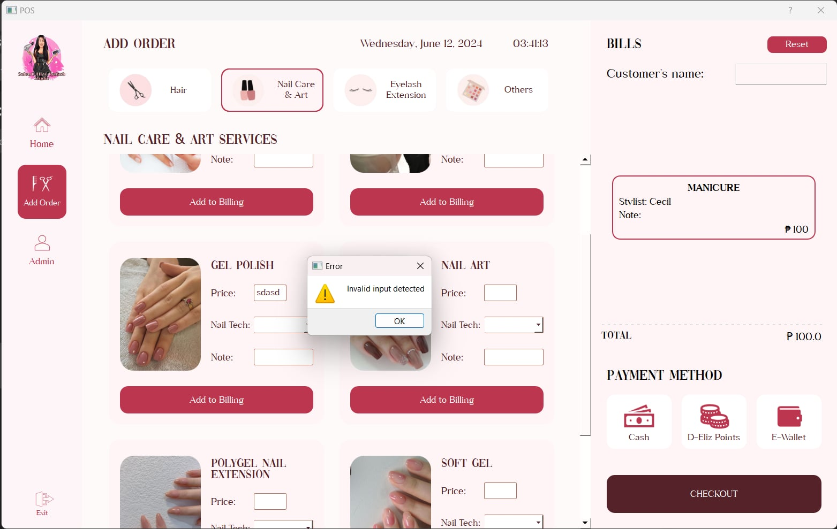

The ordering form above shows that if the user attempts to proceed with the wrong input price for gel polish, the system will display an error message prompting to “Invalid input detected” since the user inputs are non-numeric characters for the price and/or the stylist/nail tech combo box is empty.

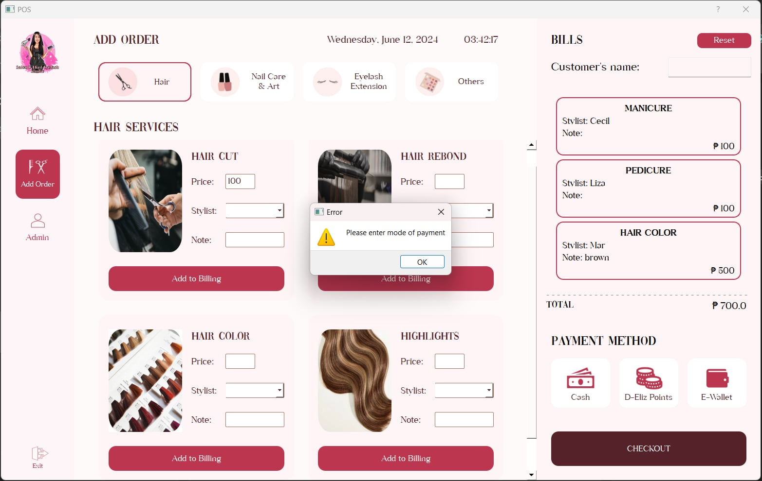The ordering form figure above shows that the user attempts to proceed without selecting a mode of payment, the system will display an error message prompting to “Please enter mode of 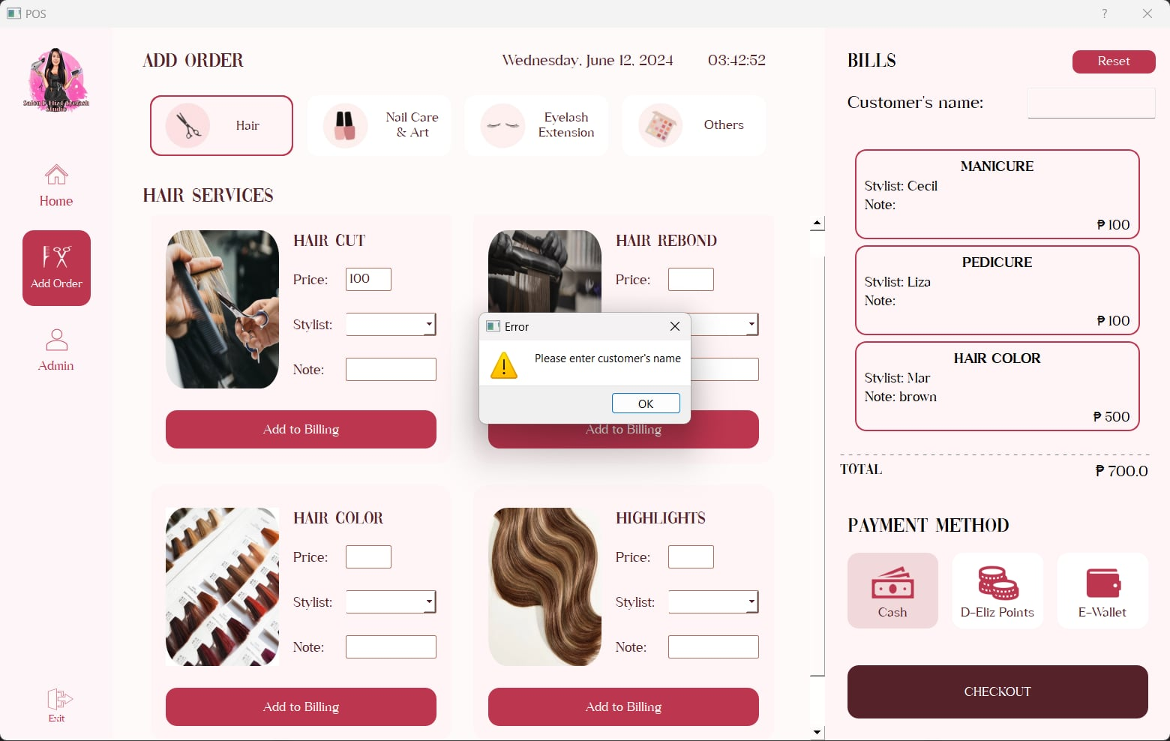payment,” ensuring that all necessary information is provided before completing the transaction.

The ordering form figure above shows that the user attempts to proceed without entering the customer’s name, the system will display an error message prompting to “Please enter 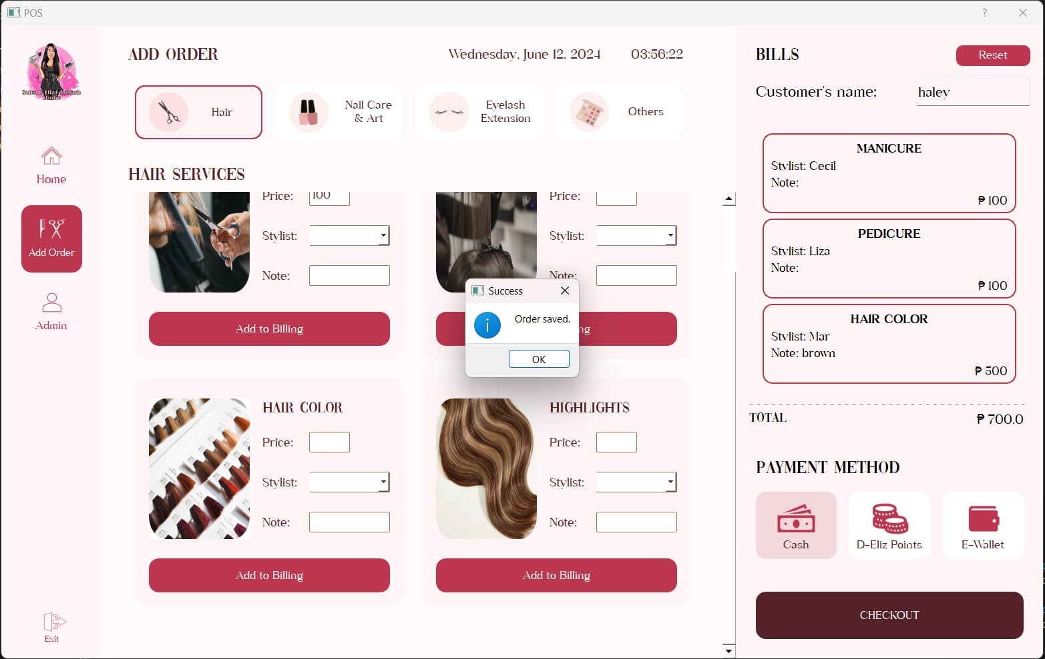customer’s name,” ensuring that all required fields are completed before finalizing the order.

The “Order saved” message will be prompt if the inputs are valid and complete.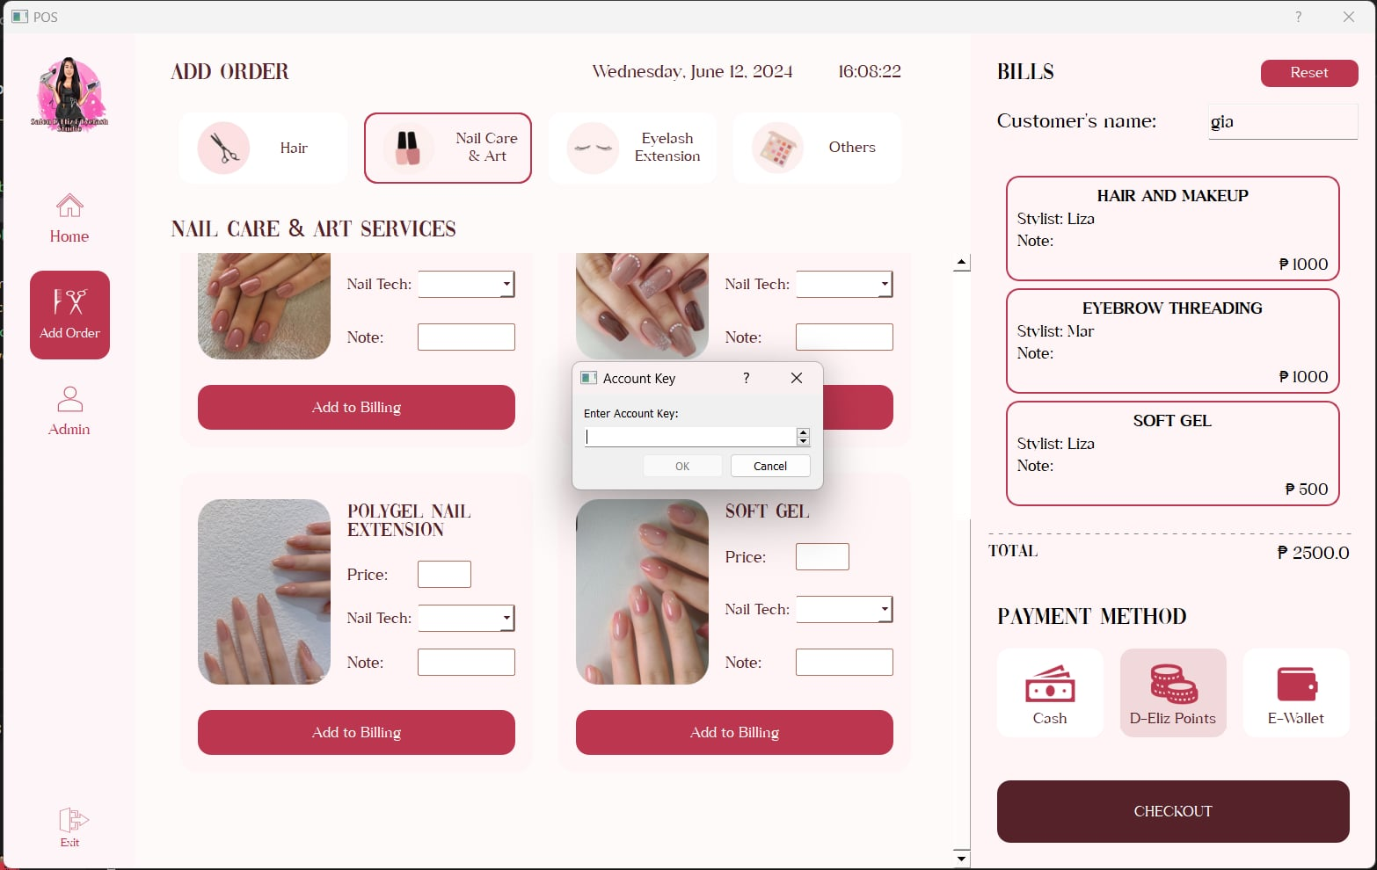

If the customer chooses D-Eliz Points as their payment, there is an account key that needs to be input, as shown in the image above.

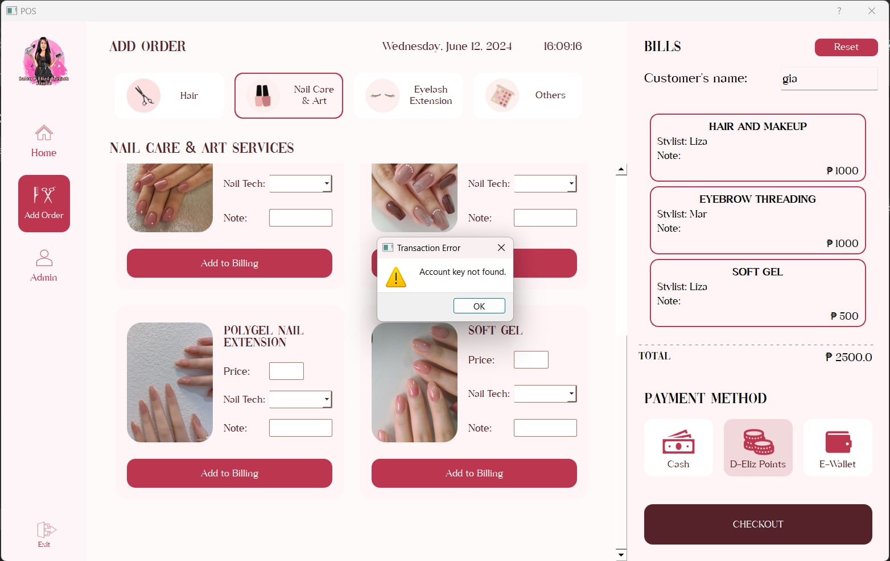

If the account key does not exist in the system’s database, the transaction will have an error message “Account key not found”

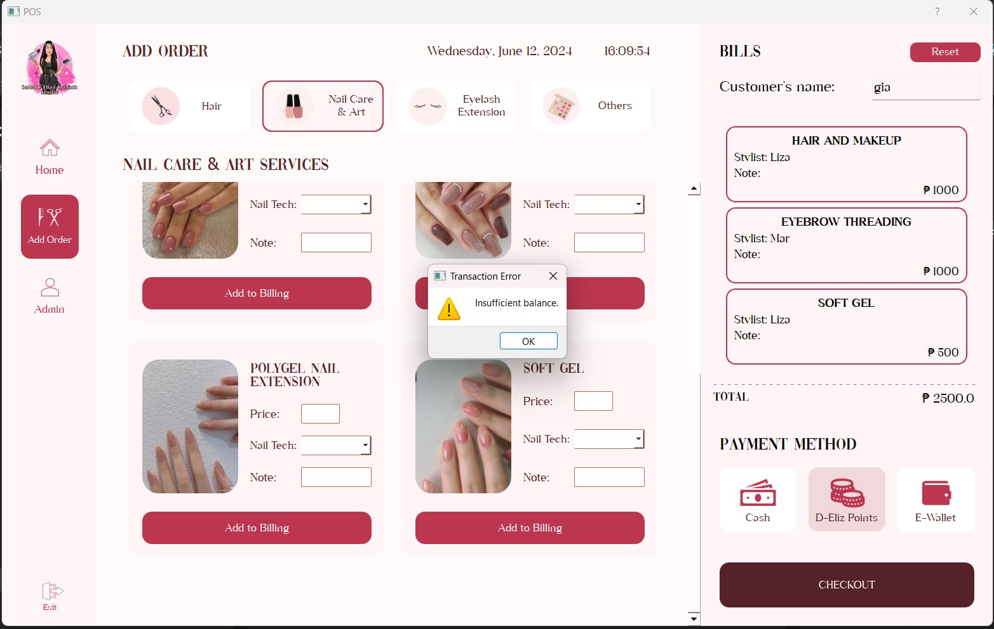

The system will search for the current point balance of the account key. If the balance is insufficient for the order transaction, the message prompts “Insufficient Balance.”

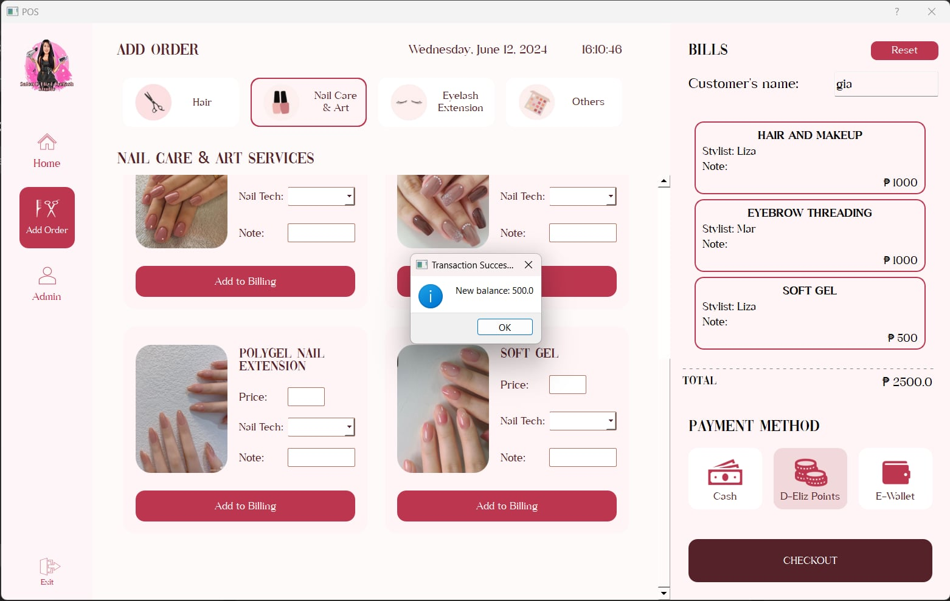

If the D-Eliz Points are successfully used as a payment method, the database will update the balance of the customer account.

**Admin Interface - List of Orders**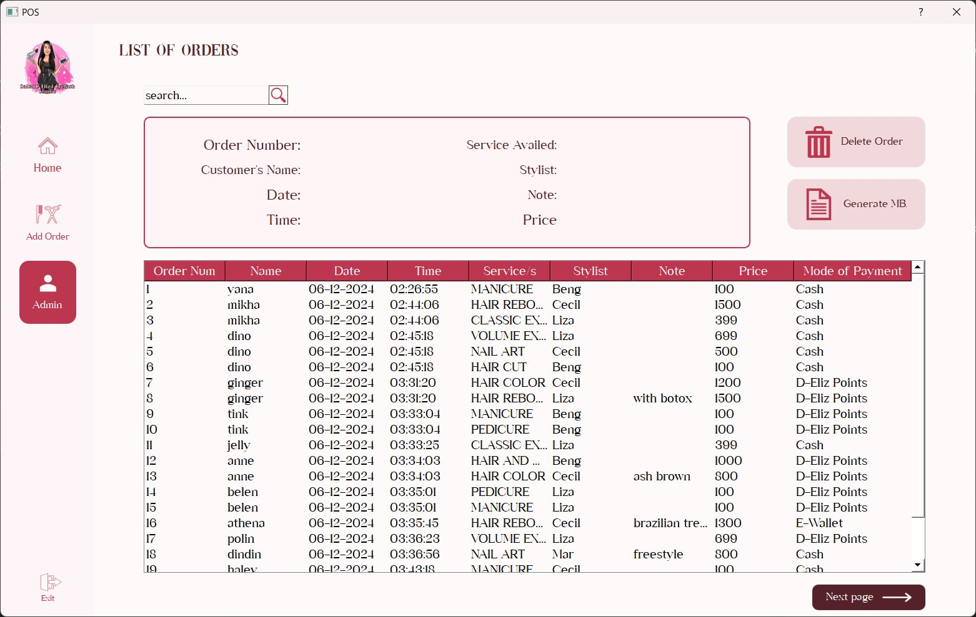

The figure above shows the salon admin interface used to view and manage customer orders. It allows users to search and see details in the table including order details, process payments, delete order and generate Market Basket Analysis.

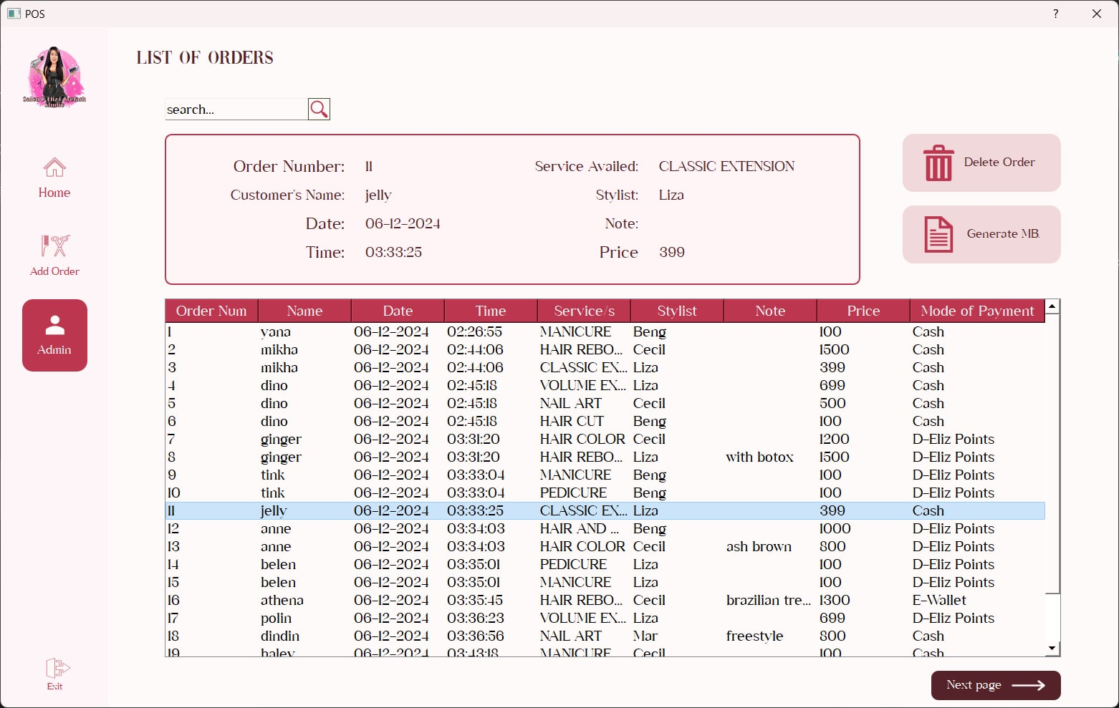

If the user clicks the column, it will automatically display the labels and text information above the table.

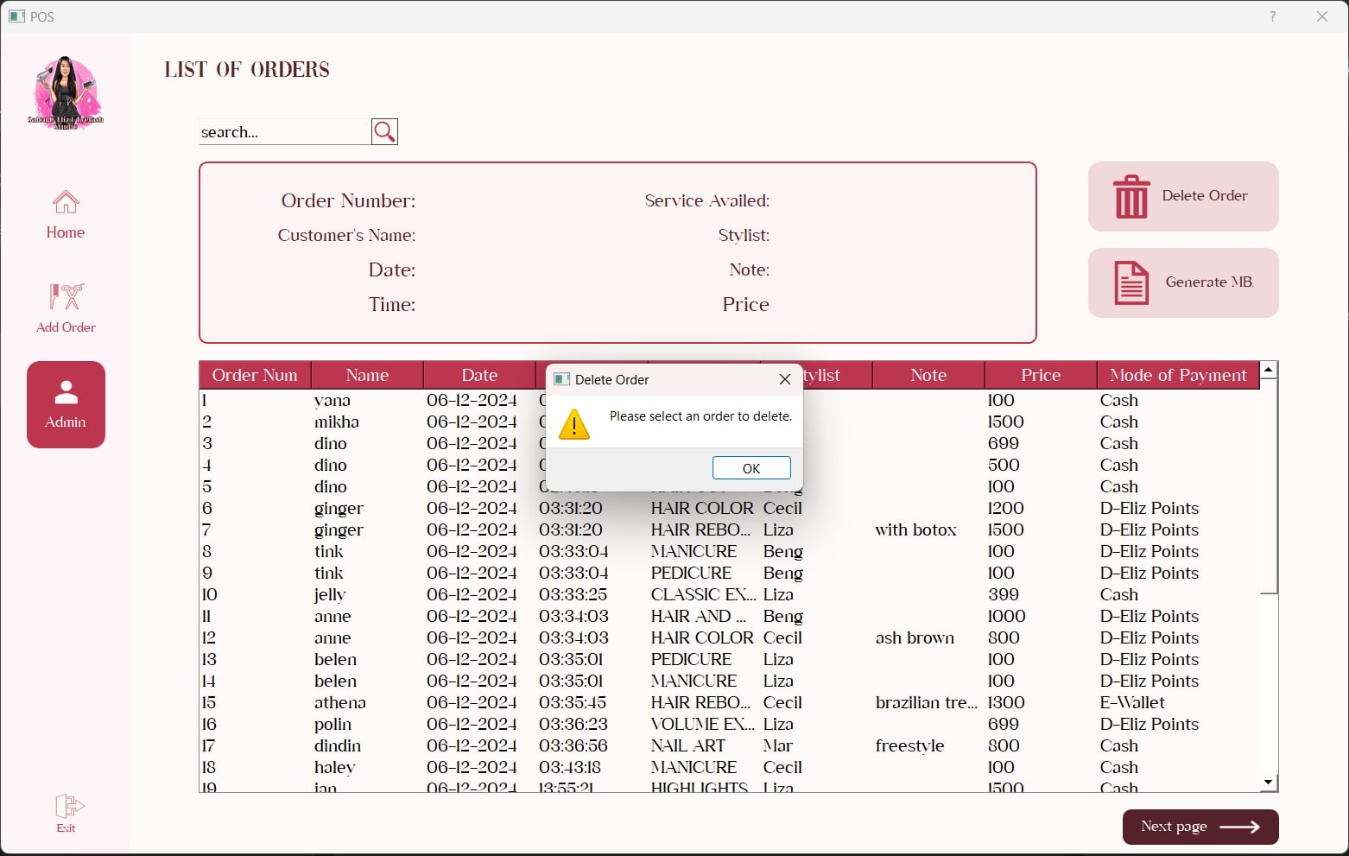

If the user wants to delete the order but did not choose a column from the table, there is prompt "Please select an order to delete" 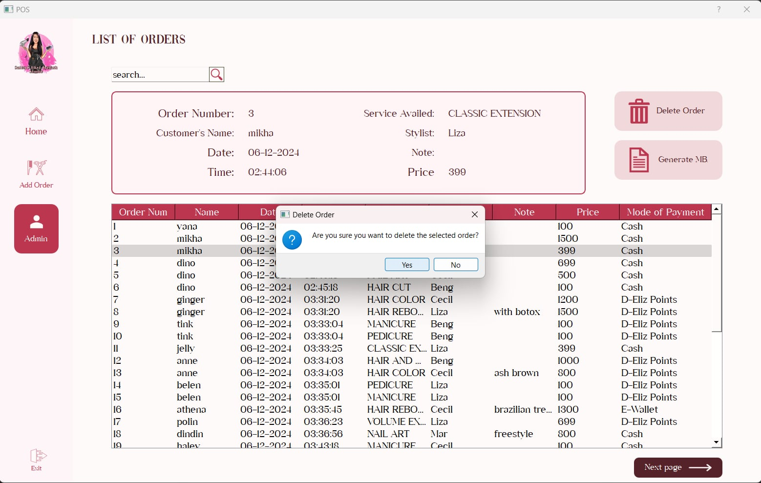

After choosing a column to be deleted and clicking the "Delete" button, the system will ask the user, "Are you sure you want to delete the selected order?" If yes, click "Yes." and it will be deleted in the database. If “No”, the deletion process will not take place.

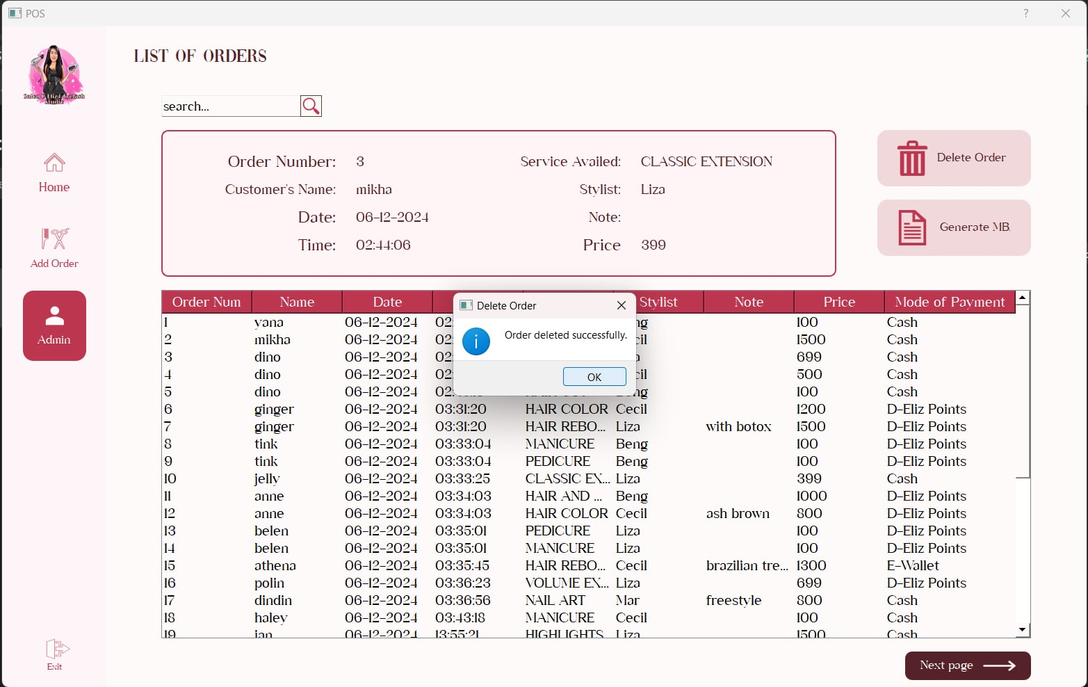

If the deletion is successful in the database, the system will prompt the message "Order deleted successfully"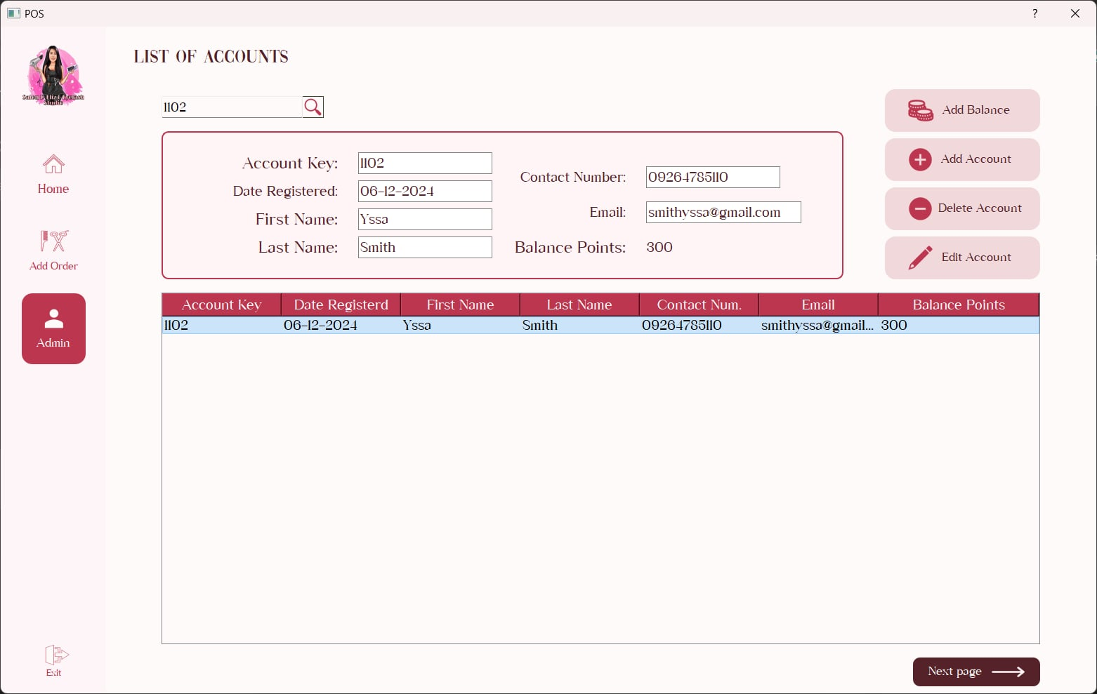

There is a search feature where the user can search any word or number existing in the database, and it will automatically show the data in the table. The user can also add balance, add an account, delete account and edit account.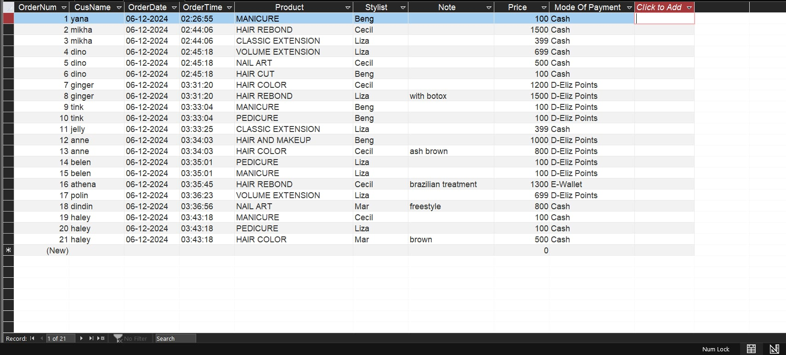

Above is the database for all order transactions, under a table named “OrderList”. The table is made of Order number, Customer’s name, Order time, Order date, Product/Service availed, Stylist, Note, Price, and Mode of payment.

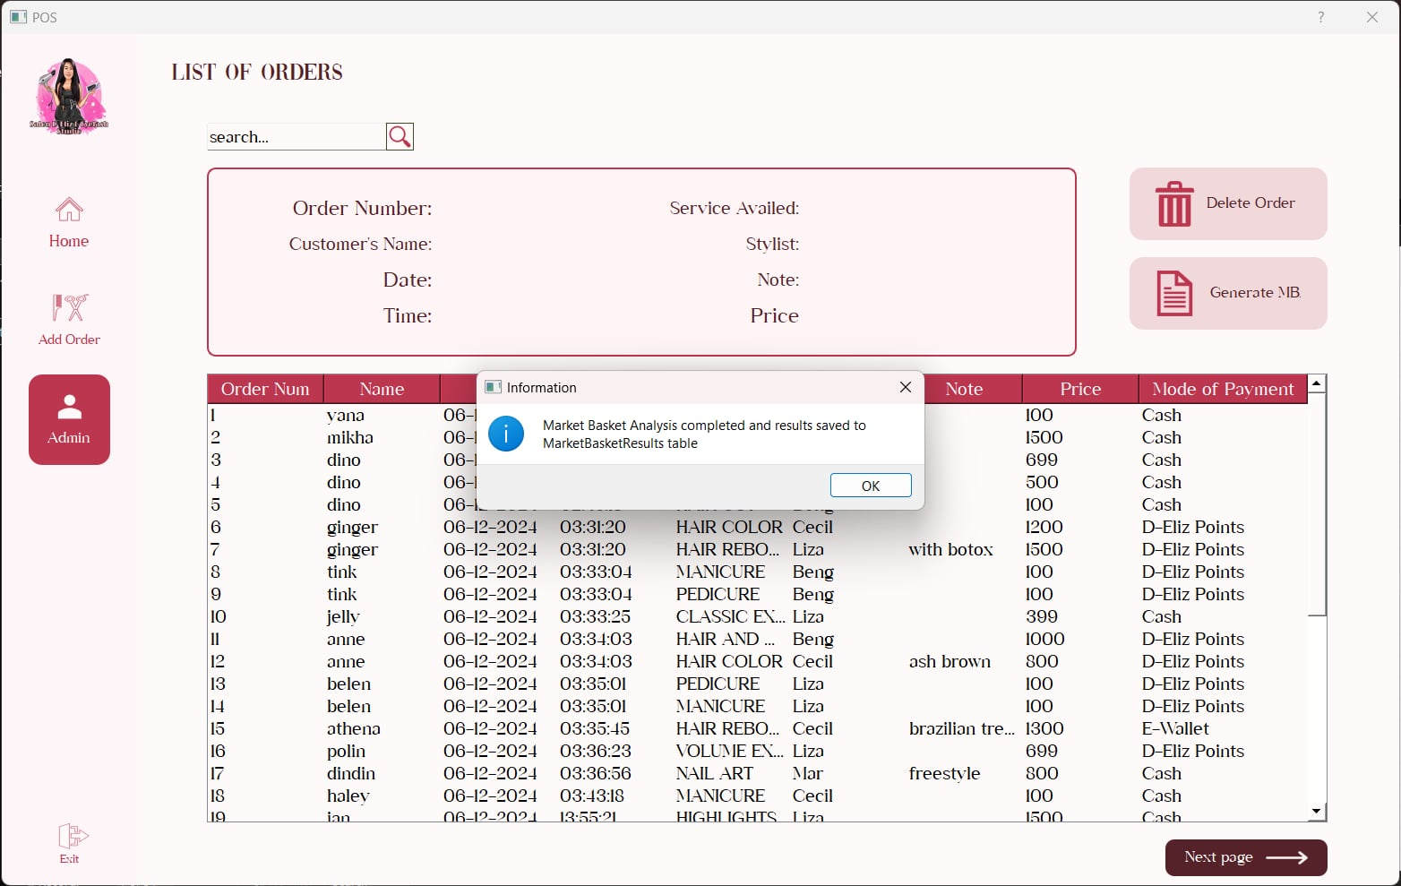

“Generate MBA” button is for generating Market Basket Analysis from the list of all order transactions found in the OrderList table in the database. If the generation is successful a 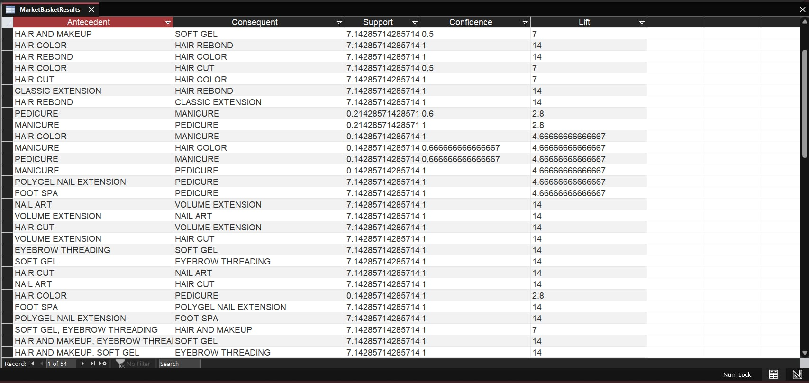prompt message will be shown.

The MBA results is stores in another table from the database named “MarketBasketResults”. The table consists of the Antecedent, Consequent, Support, Confidence, and Lift value resulted from the Market Basket Analysis using Apriori algorithm.

**Admin Interface - List of Accounts**

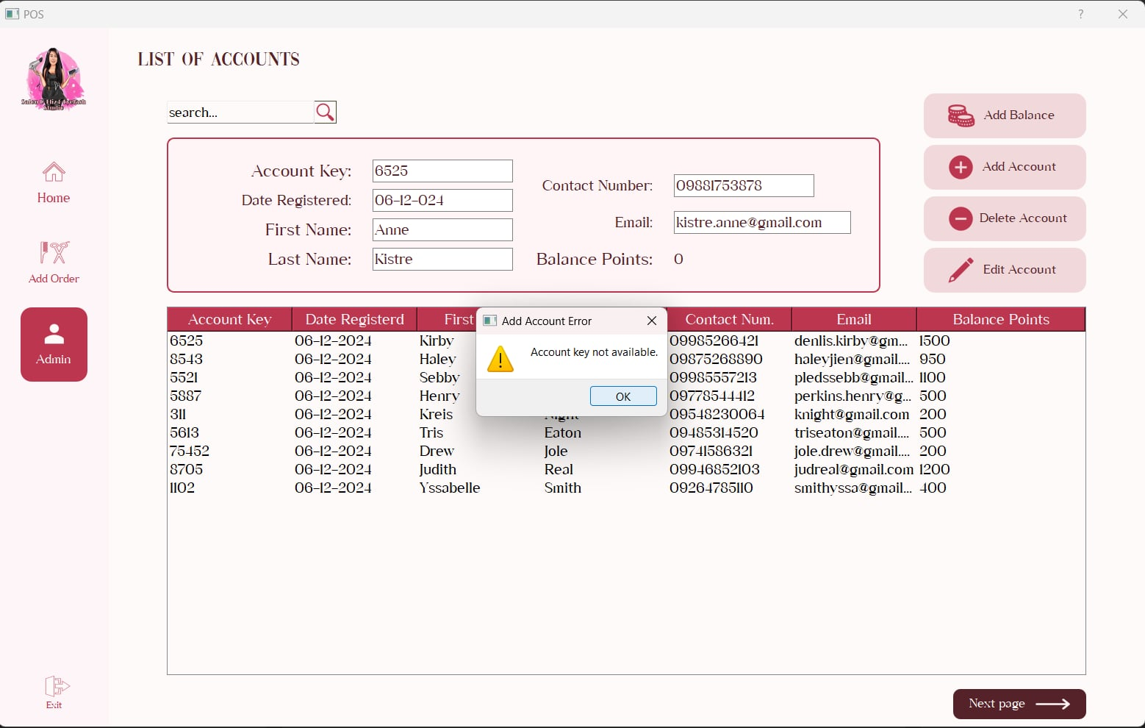

When adding a new account and there is a similar account key in the database, the add account function will prompt an error “Account key not available”.

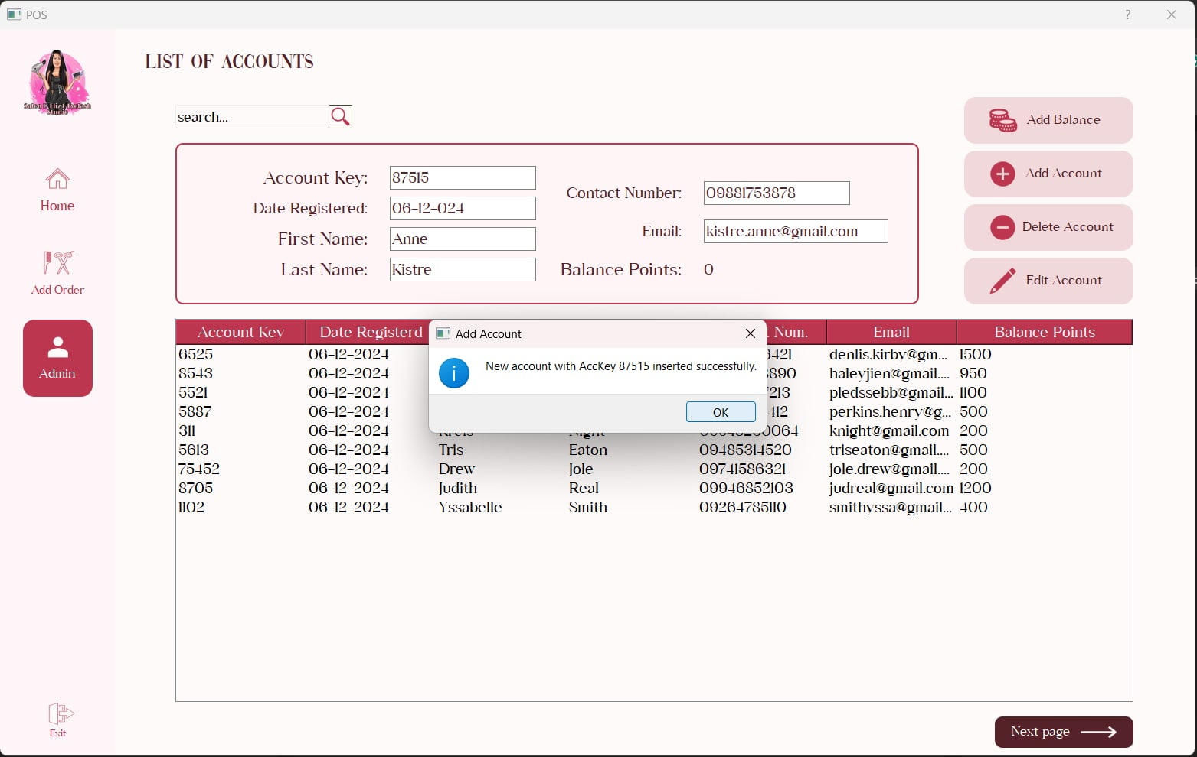

If there is no similar account in the database, it will be successful and will prompt the message "New Account with AccKey #### instead successfully". This new account will also be inserted into the Accounts database.

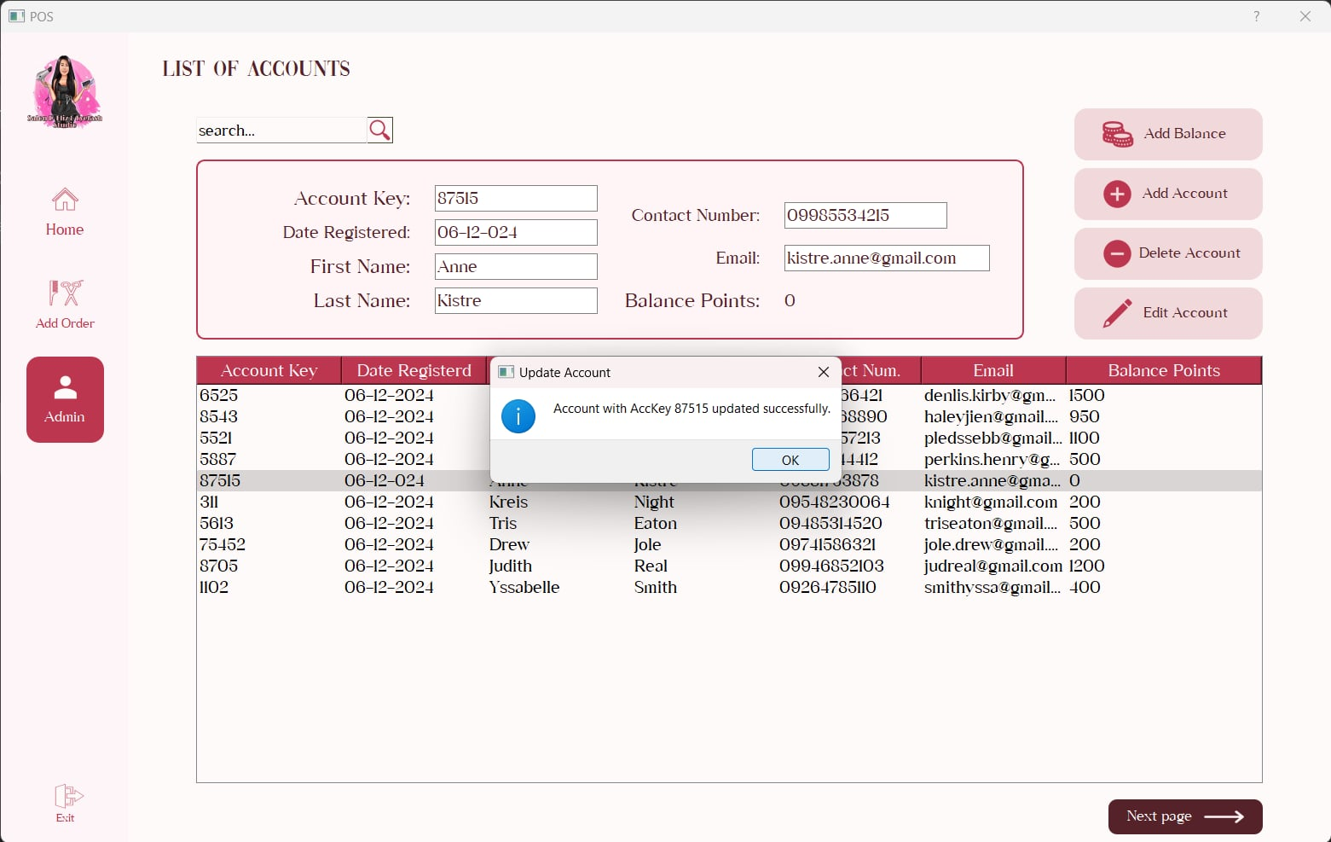

The account will be updated if the account will be existing in database, the user can edit the account’s information through the line edits in the UI. All information can be edited aside from the account key and balance points.

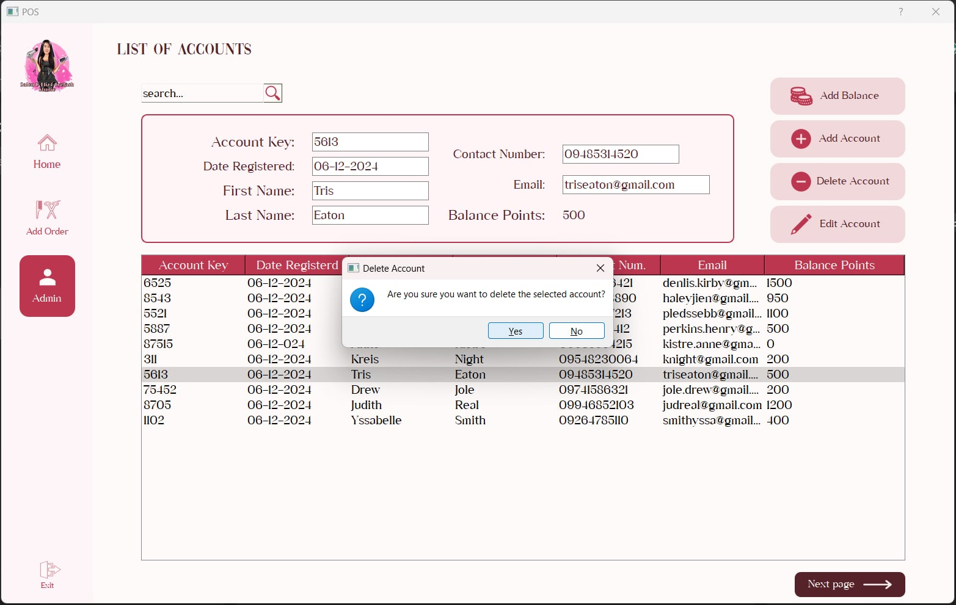

For the “Delete” button function, a column from the table needs to be clicked first then the system will ask the user, "Are you sure you want to delete the selected order?" If yes, click "Yes." and it will be deleted in the database If no, then click "No".

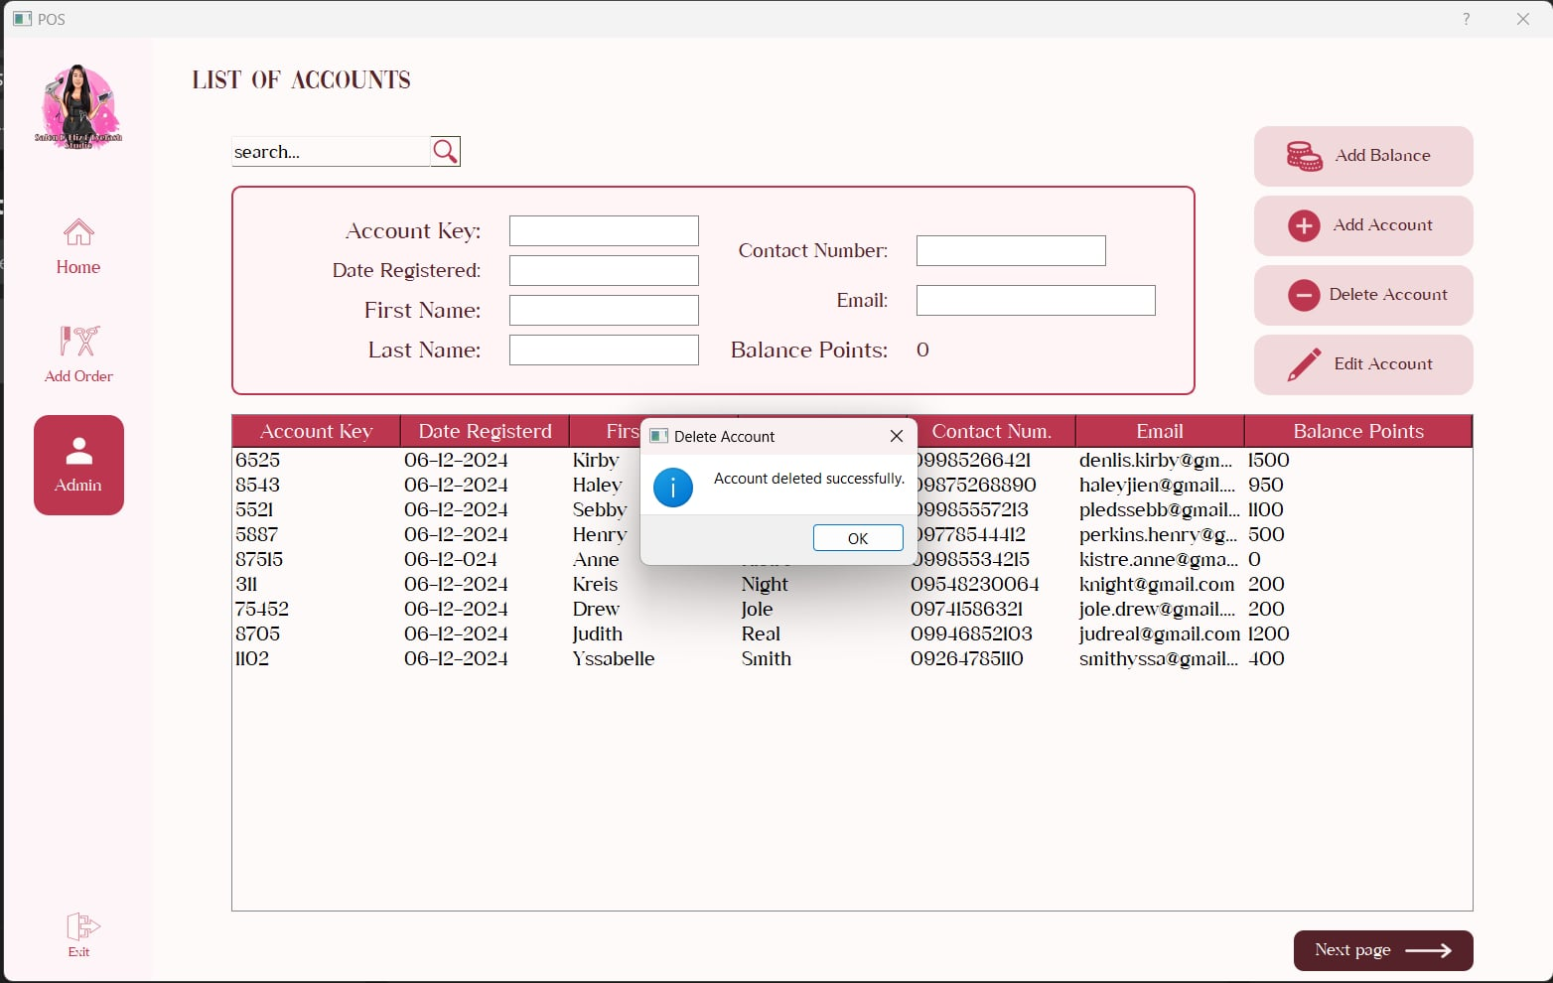

If the deletion is successful, the system will prompt the message "Account deleted successfully". The deletion also reflects to the Accounts database.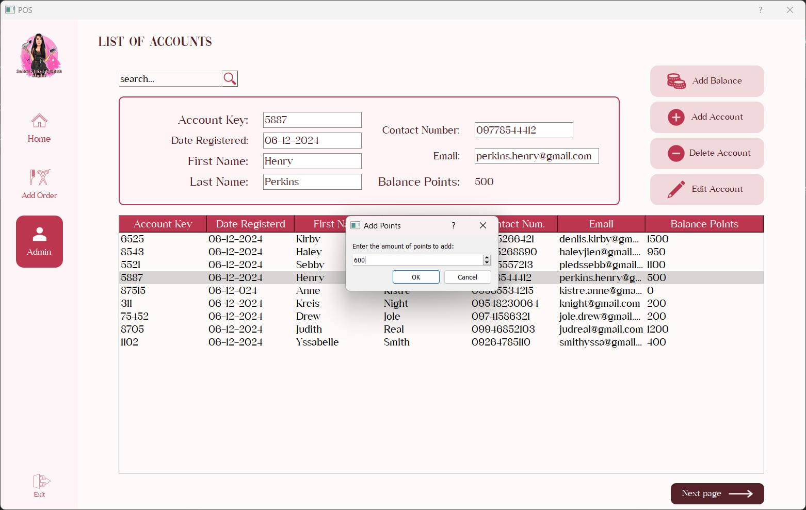

For the “Add Balance” button, after an account was clicked or chosen from the table, the system will display an input prompt to enter the balance points to be added in the account.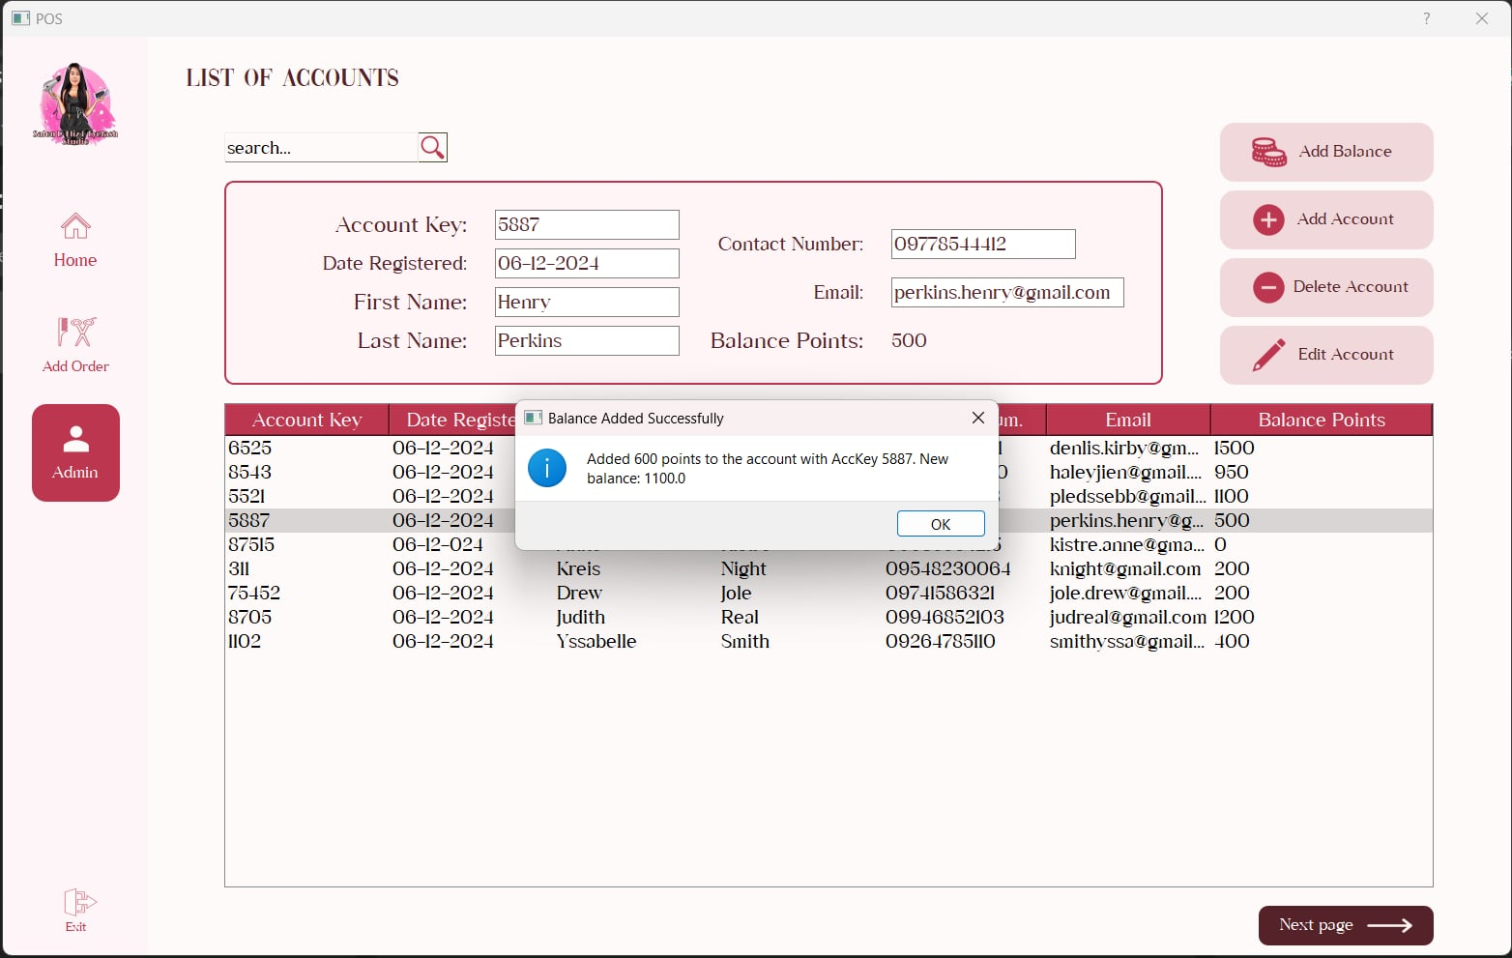

The system will then fetch the current balance points of the account from the database, then add the points entered by the user, and save the current balance points of the account in the database.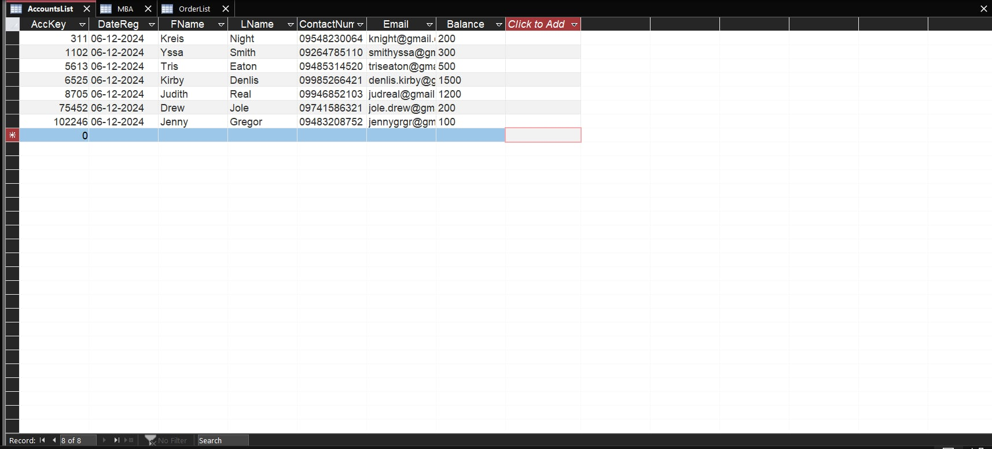

Above is the database for the accounts, which is under the table “AccountsList”. It has the Account key, Date registered, First name, Last name, Contact number, Email, and Balance information of every account.

**Project Capabilities and Limitations**

This project BasketXpertPOS: Where Intelligence Meets Efficiency for System Salon D-Eliz offers a comprehensive solution for clients that provides a cashless payments transaction, point of sale system, personalized services, product recommendations, inventory management through transaction analysis. While the system provides many capabilities, it also has limitations that require careful consideration and strategic planning to overcome.

**Project Capabilities**

**Cashless Transactions -**  It has capabilities to support cashless payments, e- wallet, enhancing convenience and security for payment options.

* Integrates with various payment gateways for credit/debit card and e-wallet payments.
* Provides seamless and secure transactions for customers.
* Generates real-time transaction reports for easy financial tracking.

**Services Recommendations -** The system provides personalized services suggestions based on customer preference of services.

* Uses an expert system to match customer data with suitable services.
* Suggests products tailored to individual customer needs.

**Analytics and Reporting -**The system also has insights through analytics and reporting tools.

* Generates reports on appointment trends, popular services, inventory usage, and financial transactions.
* Helps in making informed business decisions.

**Project Limitations**

**Manual Addition of New Services -** Should the beneficiary desire to add new items to the salon, it will be done so manually by the developers.

* No feature in the system to add service on the admin side.
* The developers must intervene in the addition of these changes.

**No QR transaction -** QR reading not included in this program

* Customers can only refer to their balance on the acc database.
* Other cashless transactions are through the use of GCash, depending on the availability of the cashier.

**Non Flexible** - This POS is designed strictly for the beneficiary’s preferences .

* While it does resemble the features of a traditional point of sale, most contents are exclusively for the owner of Salon D-Eliz.
* Should other beneficiaries want the same kind of system, it must be re-designed by the developers to fit their needs.

**Project Evaluation**

The project will undergo evaluation using ISO 25010, alternatively recognized as "Systems and software engineering – Systems and software Quality Requirements and Evaluation (SQuaRE) – System and software quality models" by the developers.

The following are the steps to be conducted to evaluate project:

1. Assemble a diverse group of 40 carefully chosen participants , compromising (20) regular salon customers, (10) individuals knowledgeable about salon management or business management, and (10) students specializing in computer-related courses.
2. Conduct a comprehensive guidance session to familiarize participants with the BasketXpertPOSfeatures, emphasizing effective navigation and usage.
3. Allow participants to explore and interact with the BasketXpertPOS a Point of Sale System with Market Basket Analysis, fostering a genuine user experience.
4. Provide respondents with evaluation sheets featuring a 4-point Likert scale. Instruct them to assess various aspects of the salon web application, covering usability, performance, and overall satisfaction.
5. Collect and compile the evaluations and assessments from respondents, ensuring a comprehensive overview of their insights and opinions.
6. Analyze the gathered data.

| Scale | Adjectival/Descriptive Rating | Range |
| --- | --- | --- |
| 4 | Highly Acceptable | 3.4 – 4.0 |
| 3 | Very Acceptable | 2.6 – 3.3 |
| 2 | Acceptable | 1.8 – 2.5 |
| 1 | Not Acceptable | 1.0 – 1.7 |

**Table 1. 4 Point Likert Scale**

The table above shows the 4-point Likert Scale that includes the adjectival/descripting rating, scale, and range for each rating. This will be used for the assessment of the system based on various categories of the features of ISO 2010.

**Respondents**

| **Type of Respondent** | **No. of Respondents** | **Percentage** |
| --- | --- | --- |
| Professional | 15 | 50 |
| Non-profesional | 15 | 50 |
| **Total** | 30 | **100** |

# **Test Results:**

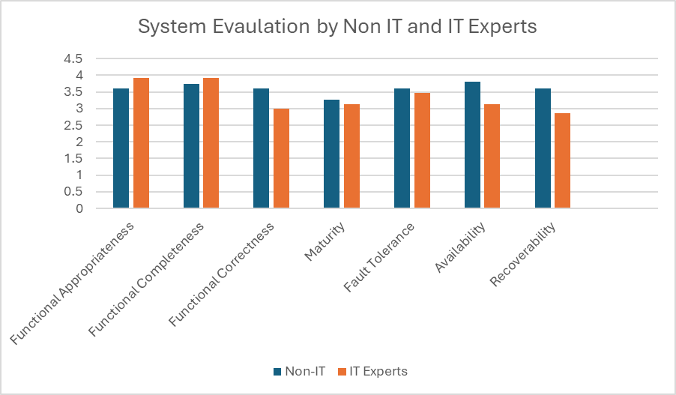

**Fig 8. Test Results - System Evaluation by Non IT and IT Experts Graph**

After receiving the evaluation results from both Non-IT respondents and IT experts, 7 areas of evaluation were acquired, it is the weighted mean of all the respondents’ answers in 7 areas of evaluation. For functional awareness, Non-IT respondents’ responses got a weighted mean of 3.6 and the IT Experts’ responses got a weighted mean of 3.93. This indicates that both respondents highly accept the functional completeness of the system, indicating that the system’s features are completely functioning. Another area of evaluation is the Functional Completeness, garnering a weighted mean of 3.73 from Non-IT respondents and 3.93 from IT Experts. Both can be interpreted as “Highly Acceptable”, indicating that the system covers all tasks and user objectives. Another area of evaluation is Functional Correctness, garnering a weighted mean of 3.6 from the Non-IT respondents and 3.0 from IT Experts gaining a verbal interpretation of “Highly Acceptable” from Non-IT respondents and “Very Acceptable” from IT Experts indicating that the system is produce accurate results on par with the required level of accuracy. Another area of evaluation is the maturity in which the system satisfies reliability requirements to which it can avoid failures due to defects in the system. This garnered a weighted mean of 3.26 from the Non-IT respondents and 3.13 from IT experts, having a verbal interpretation of “Very Acceptable” from both respondents. This indicates that the system is seen as matured enough to satisfy reliability requirements. Another area of evaluation is the Fault Tolerance which garnered a weighted mean of 3.6 from Non-IT respondents and 3.47 from IT experts both having a verbal interpretation of “Highly Acceptable” indicating that the system still gracefully works under encountering faults or errors. Availability, another area of evaluation, garnered a weighted mean of 3.8 from Non-IT respondents and 3.13 from IT personnel having a verbal interpretation of “Highly Acceptable” and “Very Acceptable” respectively, indicating that the system is accessible when required to use. Lastly, another area of evaluation, is the Recoverability which garnered a weighted mean of 3.6 from Non-IT respondents and 2.87 from IT Experts having a verbal interpretation of “Highly Acceptable” and “Very Acceptable” respectively, indicating that the system is capable of resuming its duties in the event of an error or failure.

**CHAPTER 5**

**SUMMARY OF FINDINGS, CONCLUSION, AND RECOMMENDATION**

This chapter recaps and concludes the results of the research from previous chapters. Included in this chapter is the summary of findings, final conclusions, and further recommendations for people who may want to pursue related studies to BasketXpertPOS.

**Summary of Findings**

Results from the respondent’s evaluation find that the system has successfully met its requirements and objectives. It is more obvious that the Non-IT respondents will grade the system higher than the IT Experts due to their evaluation skills and the know-how about system developing. Overall, the grand weighted mean for the Non-IT respondents is 3.60, having a verbal interpretation of “Highly Acceptable” and a grand weighted mean of 3.35 for the IT Experts’ evaluation, having a verbal interpretation of “Very Acceptable”.

**Conclusion**

The developers successfully developed a point of sale system for Salon D-Eliz, meeting their criteria, parameters and standards based on their preference on this system. It has successfully met all its objectives, particularly the building of a POS with a cashless feature and database features ensuring the proper management of data entered within the system. It has met the objectives and the beneficiaries were satisfied with the outcome of the system.

**Recommendations**

After developing the systems, several rooms for improvement are present and are therefore recommended in this section.

1. Make the database more complex and functional, use a Relational Database rather than a Non-Relational Database.
2. Be able to enable the beneficiary to edit, add, or delete items/services of their business without intervention from the developers.
3. Make a more sophisticated mode of payment in terms of cashless transactions such as QR-Enabled payment directly through the system.
4. Make the functionality of the database smoother, more accurate, functional, and responsive.
5. Make the system flexible, meaning it is not only designed for one beneficiary or type of business.

**References**

[1] Damen, A. (2023, January 31). Cashless Payments: Pros, Cons, How to Accept Them, & 8 Types. MONEI. Retrieved January 18, 2024, from https://monei.com/blog/cashless-payments/

[2] Lim, N. (2020, July 3). Pros and Cons of Cashless Businesses. AppDirect. Retrieved January 18, 2024, from https://www.appdirect.com/blog/cashless-payment-advantages-and-disadvantages-should-your-business-go-cashless

[3] Crismundo, K. (2023, June 1). Study shows Filipinos' cashless payments increasing. Philippine News Agency. Retrieved January 18, 2024, from https://www.pna.gov.ph/articles/1202675

[4] Li, T. (2023, September 29). What Is a POS System and How Does It Work? Investopedia. Retrieved January 18, 2024, from https://www.investopedia.com/terms/p/point-of-sale.asp

[5] What is market basket analysis? Definition from WhatIs.com. (2019). TechTarget. Retrieved January 18, 2024, from https://www.techtarget.com/searchcustomerexperience/definition/market-basket-analysis

[6] Acharya, M. (2022, May 4). How to do Bookkeeping. Cleartax. https://cleartax.in/s/how-to-do-bookkeeping

[7] Schnitt, D. (2023, October 27). The challenges of having a manual accounting system | IQ BackOffice. IQ BackOffice. https://www.iqbackoffice.com/the-challenges-of-having-a-manual-accounting-system/

[8] Mark. (2024, April 13). Digital Bookkeeping! Is your business ready? Stewart Accounting. https://stewartaccounting.co.uk/digital-bookkeeping-is-your-business-ready/

[9] Hayes, A. (2023, December 20). What is a POS system, and how does it work? Investopedia. <https://www.investopedia.com/terms/p/point-of-sale.asp>

[10] Mackay, A., & Wilmshurst, J. (n.d.). Fundamentals and Practice of Marketing. https://books.google.co.id/books?id=lDLDDwAAQBAJ&lpg=RA1-PA16&dq=definition%20of%20point%20of%20sales%20system&pg=RA1-PA16#v=onepage&q&f=false

[11] 27 Advantages of a POS System. (n.d.). Alice POS. Retrieved January 20, 2024, from https://alicepos.com/27-advantages-of-a-pos-system/#technical-technological-support

[12] Crawford, H., & Lauckner, S. (2023, August 24). What Is a POS System and How Does It Work? NerdWallet. Retrieved January 20, 2024, from https://www.nerdwallet.com/article/small-business/what-is-a-pos-system

[13] Khalid, S., & Mand, N. (2022). POINT OF SALE SYSTEM. https://papers.ssrn.com/sol3/papers.cfm?abstract_id=4368998&download=yes

[14] Sjarif, N. N. A., Azmi, N. F. M., Yuhaniz, S. S., & Wong, D. H.-T. (2021). A review of market basket analysis on business intelligence and data mining. International Journal of Business Intelligence and Data Mining, 18(3), 383-394. https://www.inderscienceonline.com/doi/abs/10.1504/IJBIDM.2021.114475?fbclid=IwAR1DtqX_FWPDUmOkuobudVudv-McWkq9clr75mp7N-N4U_qZjvJSratLSDk

[15] Understanding Market Basket Analysis in Data Mining. (n.d.). Turing. Retrieved January 20, 2024, from https://www.turing.com/kb/market-basket-analysis

[16] Turing. (2019). Turing. Market Basket Analysis: Anticipating Customer Behavior. Retrieved January 20, 2024, from https://www.turing.com/kb/market-basket-analysis

[17] Ansari, S. Z. (2019, February). MARKET BASKET ANALYSIS: TREND ANALYSIS OF ASSOCIATION RULES IN DIFFERENT TIME PERIODS. https://run.unl.pt/bitstream/10362/80955/1/TEGI0458.pdf

[18] Behera, M., Fartale, A., Bhagat, A., & Sharma, P. N. (2018, February). Market Basket Analysis based on frequent Itemset Mining. International Research Journal of Engineering and Technology (IRJET), 5(2), 414-417. https://www.irjet.net/archives/V5/i2/IRJET-V5I297.pdf

[19] Shetty, S. (2023). What is Apriori Algorithm? Apriori Algorithm Explained. Retrieved January 21, 2024, from https://www.mygreatlearning.com/blog/apriori-algorithm-explained/?fbclid=IwAR3gdbo12Z54R-dictfMOR40b634hHAAzadIMGns1Uqi_Pa9Bu31DPscoB0

[20] What is market basket analysis? Definition from WhatIs.com. (2019). TechTarget. Retrieved January 18, 2024, from https://www.techtarget.com/searchcustomerexperience/definition/market-basket-analysis

[21] R, A. (2021, April 26). Cashless transaction - Benefits and types of cashless payment methods. Essential Business Guides. https://www.zoho.com/books/articles/cashless-payments.html

[22] Bank, I. F. (2023, December 28). Cashless transaction - Advantages of cashless transactions | IDFC FIRST Bank. Idfcfirstbank. https://www.idfcfirstbank.com/finfirst-blogs/mobile-banking/cashless-transaction

[23] SAQUIN, M., BOYBOY, J., CANON, J. M., DELACRUZ, C. A., DELACRUZ, L., JORGE, D., JR, & MACALINAO, M. A. (n.d.). CASHLESS TRANSACTION THROUGH E-WALLET: ANALYSIS OF PERCEPTION AND USAGE INTENTION OF MICRO BUSINESS OWNERS IN CAVITE [Cavite State University – Tanza Campus]. https://doi.org/10.37602/IJREHC.2024.5108